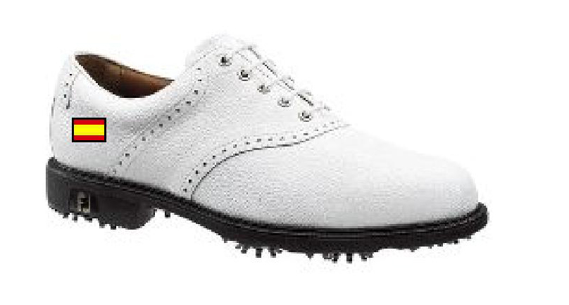
My Joys 53510 (White)
FOOT JOY SHOES 2010

UK / US SIZES (Women) | 2010 ORDER (received)
4,5 / 6 | 1 / 2
5 / 6,5 | 4
5,5 / 7 | 6/8
6 / 7,5 | 10
6,5 / 8 | 10
7 / 8,5 | 12/10
7,5 / 9 | 12/10
8 / 9,5 | 8/2
8,5 / 10 | 1/0

64 recibidos 56 pares

WATER PROOFS

SIZE (Women) | 2010 ORDER  2 jackets  15 (10 | Jackets | Pant.
XS | 0 | 2
S | 15 | 10
M | 14 | 17 | M corta 9  M larga 5
L | 5 | 5 | 24
XL | 6 | 6 | 2

