Arroyo del Monte 5. 28035 MADRID - T: (34) 913 769 130 - F: (34) 915 563 290 - rfegolf@rfegolf.es - www.rfegolf.es

SPANISH INTERNATIONAL LADIES’ AMATEUR CHAMPIONSHIP
“COPA DE S.M. LA REINA”
El Valle Golf Resort. February 29th – March 4th, 2012
Counting event for the WWAGR

VENUE: El Valle Golf Resort
Autovía San Javier – Murcia km. 4, exit C3319. Baños y Mendigo. 30155 MURCIA
Tel.: 968 033 002; Fax: 968 032 770
Email: elvalle@murciagolfexperience.com
Nearest airports:
San Javier – Murcia Airport: 15 minutes driving time to the Golf Club.
Alicante International Airport: 60 minutes driving time to the Golf Club.

More information on the golf site:
http://golf.marmenorresort.com/comollegar

PROGRAM:
Sunday February 26th Players’ arrival
Monday February 27th First Practice round
Players’ registration at the Golf Club Pro-Shop
Tuesday February 28th Second Practice round
Players’ registration before 12:00 hrs (Golf Club Pro-Shop)

Wednesday February 29th First Stroke Play qualifying round (18 holes)
Thursday March 1st Second Stroke Play qualifying round (18 holes)
Friday March 2nd First Match Play round (1/16 Final)
Second Match Play round (1/8 Final)
Saturday March 3rd Third Match Play round (1/4 Final)
Fourth Match Play round (Semifinal)
Sunday March 4th Final over 18 holes
12:30-13:00h. approx. Prize Giving Ceremony.

OFFICIAL PRACTICE ROUNDS:

Official practice days free of charge are Monday and Tuesday, February 27th & 28th.
Practice times may be requested to El Valle Golf Resort by phone or email after the official list participants has been published on February 9th.

ENTRIES:
Entries must be submitted ONLINE http://www.rfegolf.es by 23:59 hours, February 8th, 2012.
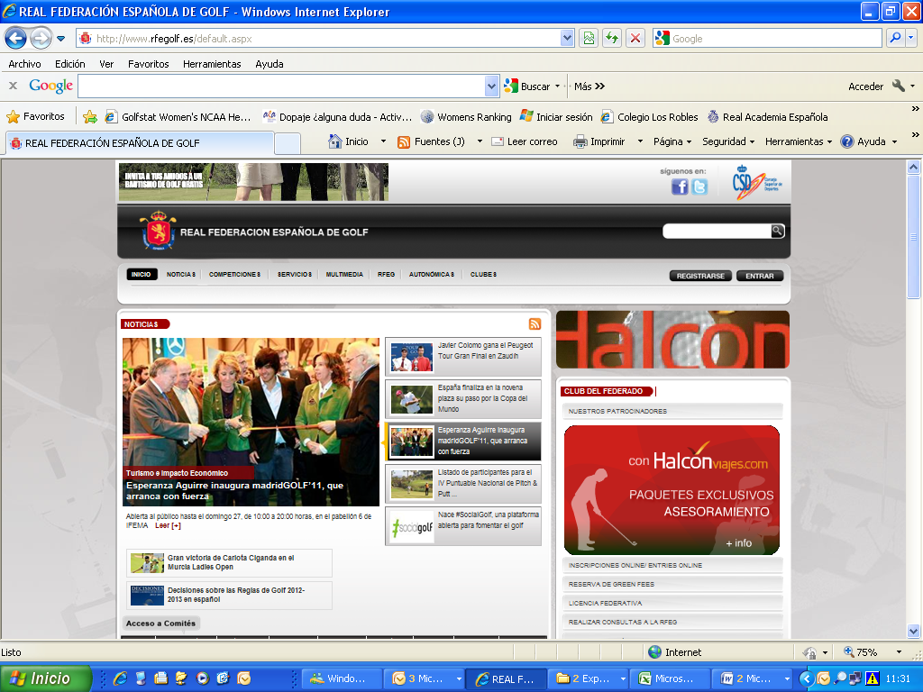

Players should select the competition, click on “online entries” and then click on the box: “I am a foreign player” for fill out player’s details.
Players can also require their federation to submit their entry form on their behalf.
Players are responsible to check if their entry form has been accepted. Any claims must be submitted within the next 24 hours after the list of participants has been published.

The entry fee must be paid upon registration at the Golf Club. Handicap limit is 6.4.
Nation’s Cup entry forms (page 4) must be returned by 18:00h, February 8th, 2012.

REGISTRATION:
Players must register at the Golf Club reception as soon as possible during the times stated below and no later than 12 noon on Tuesday March 1ST. Registration will take place in El Valle Golf Resort as follows:

- Monday February 27th (from 9:00 to 17:00 hrs – Pro-Shop)
- Tuesday February 28th (from 8:00 to 12:00 hrs – Pro-Shop)
At registration players will pay the entry fee of €80 or €40 (if born 1991 or later).

NATIONS CUP: Entry form on page no. 4

CONDITIONS: Enclosed on page no. 5

CADDIES: Condition of the Competition – the Committee applies the Note on Rule 6-4, prohibiting Professional golfers to caddie.

ELECTRIC TROLLEYS:

The Golf Club has a limited amount of electric trolleys. Players may direct their requests to El Valle Golf Resort by phone or e-mail and they will be treated on a first come first served basis; requests received prior February 9th will be discarded.

ACCOMMODATION:

Interested Players must return the Accommodation booking form (page 6) to HOLEGOLF EVENTOS90 by email, not later than February 18th, 2012.
Confirmations will be sent after the list of participants has been published.

Should you require any additional information, please feel free to contact us on +34 91 555 26 82 or by email, rfeg@rfegolf.es .

The Royal Spanish Golf Federation looks forward to seeing you in El Valle Golf Resort.

SPANISH INTERNATIONAL LADIES’ AMATEUR CHAMPIONSHIP
El Valle Golf Resort. February 29th – March 4th, 2012

NATIONS CUP ENTRY FORM

COUNTRY:

A | PLAYERS | Handicap
A | 1.
A | 2.
A | 3.

B | PLAYERS | Handicap
B | 1.
B | 2.
B | 3.

C | PLAYERS | Handicap
C | 1.
C | 2.
C | 3.

CLOSING DATE OF ENTRIES: February 8th, 2012

Arroyo del Monte 5. 28035 MADRID - T: (34) 913 769 130 - F: (34) 915 563 290 - elenavecino@rfegolf.es - www.rfegolf.es

CONDITIONS

Eligibility:
All amateur ladies in possession of their National Federation or Union Membership Card are eligible to play. Handicap limit is 6.4. The exact handicap certified at date of entry will be used for all purposes. Past Spanish Ladies Amateur Champions will have a wild card to participate.

All entries will be subject to the approval of the Ladies’ Amateur Technical Committee which reserves the right to accept or refuse, or having been accepted, subsequently reject any entry without giving any reason for its decision.

The starting field will comprise 80 competitors from Condition 1 & 2 below as ordered and 10 competitors under Condition 3 with a possible increase of 9 under Condition 4:

1. Any entrant in at least one of the following categories will be allocated a place in the starting field:
- The current Ladies’ British Amateur, US Women’s Amateur, European Ladies’ Amateur and Spanish Ladies International Amateur Champions.
- Playing members of the five leading teams and ties in the last playing of the Espirito Santo Trophy.
- Playing members of the teams making the semi-finals in the last playing of the European Ladies Team Championship.
- Playing members of the teams making the final in the last playing of the European Girls’ Team Championship.
- Playing members of the teams who participated in the last playing of the Vagliano Trophy.
- The leading 8 players and ties in the last playing of the Spanish Ladies’ Amateur National Individual Championship.
- The leading 4 players and ties in the last playing of the Spanish Lady-Juniors National Championship.
- The leading 4 players and ties in the last playing of the Spanish Girls’ National Championship.
- The current Spanish Under-16 National Champion.
- The leading 4 players and ties in the last completed Spanish National Ladies Ranking and Spanish National Girls Ranking.

2. Having applied Condition 1, the remaining of the 80 will comprise (a) entrants in order of the WWAGR (Women World Amaterur Golf Ranking) and, if the field is still incomplete, (b) entrants using exact handicaps.

3. The 10 lowest exact handicap players of Spanish nationality not included in groups 1 and 2.

4. The Women´s Amateur Technical Committee of the Royal Spanish Golf Federation reserves the right to increase the starting field by nine invited players, without handicap limitation.

Unsuccessful entrants will be placed on a waiting list ordered by WWAGR and if the field is still incomplete entrants with the lowest exact handicaps will be given the opportunity to compete if there are subsequent withdrawals. Withdrawals must be notified to the Ladies’ Amateur Committee no later than two days before the start of the competition. Players who violate this condition will not be able to participate in the next edition of this championship. In addition, they will be obliged to pay the entry fee or they will no longer be able to participate in any RFEG competition until this payment is cleared. Competitors must register at the Tournament Office before 12:00 a.m. on the day prior to the beginning of the Championship. Place may be forfeited by a competitor from whom no word has been received by this time.

Format:
Scratch over five consecutive days. 36 holes Stroke Play qualifying on days 1 & 2 (18 holes each day). Players returning the 32 lowest scores over 36 holes will qualify for the Match Play. Ties for the draw will be decided by card count back using the 18, 27, 30, 33, 34 and 35 last holes. The match play draw will be played over three days. Each match, including the final, will consist of one round of 18 holes; if undecided, a sudden death play-off will follow.

Entries:
Entry forms have to be submitted online through www.rfegolf.es by the announced closing date. The entry fee must be paid upon registration at the Golf Club.

Starting Times:
Stroke play starting times will be arranged by the Women’s Amateur Technical Committee. For the Match play, the Committee will arrange the starting times according to the standard 32 players match play draw.

Nations Cup:
Any country may nominate a team of two or three players. Every nation will be able to present a maximum of three teams.
Format: aggregate of the two lowest scores on each of the qualifying Stroke Play rounds. If two or more teams tie for the championship, the winner will be decided by taking into account the aggregate of the non-counting scores; if still tied, the team with the best finished individual player will be proclaimed the winner.

Prizes:
The trophy “Copa S.M. la Reina” remains in the property of the Spanish Golf Federation. Each year, the name of the winner, date, and name of the hosting club will be engraved on the trophy. The winner and the runner-up will receive replicas of the trophy provided by the Royal Spanish Golf Federation. The losing semi-finalists as well as the members of the Nations Cup winning team will receive trophies. No other trophies will be donated without the Women’s Amateur Technical Committee consent.

The Championship Committee reserves the right to alter the format of the Championship in order to achieve a result.


Eventos 90 S.L. Tel. 948 24 10 51
SOLICITUDES POR e-mail: alfaro@holegolf.com

INTERNACIONAL DE ESPAÑA FEMENINO– COPA S.M. LA REINA
El Valle Golf Resort- 29 de febrero al 4 de marzo 2012

SOLICITUD DE ALOJAMIENTO / Accommodation request:

Datos para confirmarles la solicitud de alojamiento /Details required to guarantee your reservation:
Apellidos/Surname: ______________________________________________________Nombre/Name: _______________________

Población/ City: ___________________________________ Telf. Móvil/ Mobile no.____________________________________

EMAIL – IMPORTANTE / IMPORTANT:__________________________________________________________________________

Telf. / Phone no. _____________________________________ Fax./ Fax no. ______________________________________

Jugadora (1)/ Player 1 _____________________________________________________________________________________

Jugadora (2)/ Player 2 ______________________________________________________________________________________

Tarifas por unidad y noche, para solicitudes efectuadas a través de Eventos 90 S.L.
ESTABLECIMIENTO | Cat. | BLOQUEO  No. Of rooms | Tipo de Alojamiento | Tipo de Alojamiento | Tipo de Alojamiento | Desayuno / Breakfast | Cena / Dinner
INTERCONTINENTAL  LA TORRE GOLF RESORT  En el La Torre C.G. A unos 8’ del Valle Golf’, en coche. Thai Room Spa, piscina climatizada, gimnasio, etc.  www.polarisworld.com | 5  ***** | 40 | Habitación  Individual-DUI  1 persona  Single room  95 €/noche  Con IVA | Habitación  Doble-2 camas  2 personas  TWIN  115 €/n. | Habitación  Doble +  Supletoria  3 personas  3 bedded room  135 €/n. | INCLUIDO  Buffet  Buffet included | Menú  25 € persona  Con IVA  (VAT included)
APARTAMENTOS  En El Valle Golf  En El Valle Golf. Totalmente equipados e impecables, con 2 dormitorios.  Supermercado en el Golf.  No se incluye limpieza, ni desayuno  www.polarisworld.com | 2  llaves | 20 | Apartamento 2 Dormitorios – 2 bedrooms villa  4 personas – 4 people villa  79 €/noche  Mínimo 3 noches. Minimun 3 nights  Con IVA |  |  | NO INCLUIDO  Not included  En el Club de Golf | Hay supermercado en el Golf  Supermarket on site
Precios por habitación/apartamento y noche. IVA incluido. DUI: Doble uso individual. Rates per room per night (VAT included)
Apartamento compuesto de 2 habitaciones y totalmente equipados,
Acceso gratuito a la zona de Spa & Fitness con gimnasio abierto las 24hrs, piscina cubierta de 25 m, sauna y baño de vapor. Spa & Fitness included

Fecha de llegada / Arrival date: _______________ Fecha salida/ Departure date______________

Habitación DUI / single room: _______ Doble/Twin room:_______ Doble + supletoria / 3-bedded: _______

Apartamento El Valle Golf /Villa: Nº personas/People no. ______________

FECHA LÍMITE GARANTIA SOLICITUD: 18 de Febrero 2012
Se confirmará el alojamiento, una vez publicadas las listas de jugadores admitidos RFEG

