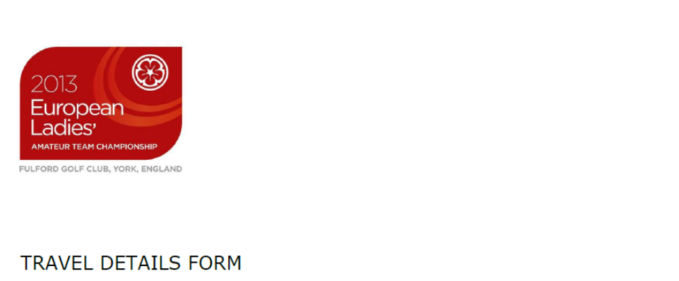
Name of federation: ROYAL SPANISH GOLF FEDERATION

NO. OF PEOPLE ARRIVING: 9
AIRPORT OF ARRIVAL AND DEPARTURE: MANCHESTER (MAN)

1ST ARRIVAL: 4 people
Flight number and airline: KL1093, KLM from Amsterdam
Date of arrival: 6 July
Arrival time & no. of persons: 16:50 hours, 4 people

2nd ARRIVAL: 3 people
Flight number and airline: AF1168, Air France from Paris CDG
Date of arrival: 6 July
Arrival time & no. of persons: 18:50 hours, 3 people (one of them comes from Palma (PMI) by Ryanair, the arrival is at the same time)

3rd ARRIVAL: 1 person
Flight number and airline: Easyjet 1924
Date of arrival: 6 July
Arrival time & no. of persons: 12:50 hours, 1 person

4th ARRIVAL: 1 person CANCELLED LOLA TELLO
Flight number and airline: AF1301, Air France
Date of arrival: 9 July
Arrival time & no. of persons: 14:40 hours, 1 person

1st DEPARTURE: 4 people
Flight number and airline: KL1074, KLM
Date of departure: 14 July
Arrival time & no. of persons: 09:15 hours, 4 people

2nd DEPARTURE: 2 people
Flight number and airline: FR3232, Ryanair
Date of departure: 14 July
Arrival time & no. of persons: 09:55 hours, 2 people

3rd DEPARTURE: 1 person
Flight number and airline: FR3445, Ryanair
Date of departure: 14 July
Arrival time & no. of persons: 13:05 hours, 1 person

4th DEPARTURE: 1 person
Flight number and airline: AF1069, AIR FRANCE
Date of departure: 14 July
Arrival time & no. of persons: 14:40 hours, 1 person

18th June, 2013

