Arroyo del Monte 5. 28035 MADRID - T: (34) 913 769 130 - F: (34) 915 563 290 - rfegolf@rfegolf.es - www.rfegolf.es

SPANISH INTERNATIONAL LADIES STROKEPLAY CHAMPIONSHIP
Las Colinas Golf & Country Club. 10 – 12 May, 2013

VENUE: LAS COLINAS GOLF & COUNTRY CLUB
Avenida de las Colinas 2
03189 ORIHUELA COSTA
(ALICANTE)
Tel.: +34 965 324 004
E-mail: golf@lascolinasgolf.es
Web: www.lascolinasgolf.es
Nearest airports: Murcia-San Javier (15 minutes driving) & Alicante (45 minutes driving)

DATES: May 10th, 11th & 12th 2013
May 9th: Official practice round.
Practice times may be requested to Las Colinas Golf by phone or email after the official list of participants has been published on April 24th, 2013.

ENTRIES: Entries must be submitted ONLINE http://www.rfegolf.es by 23:59 hours, April 23rd, 2013.
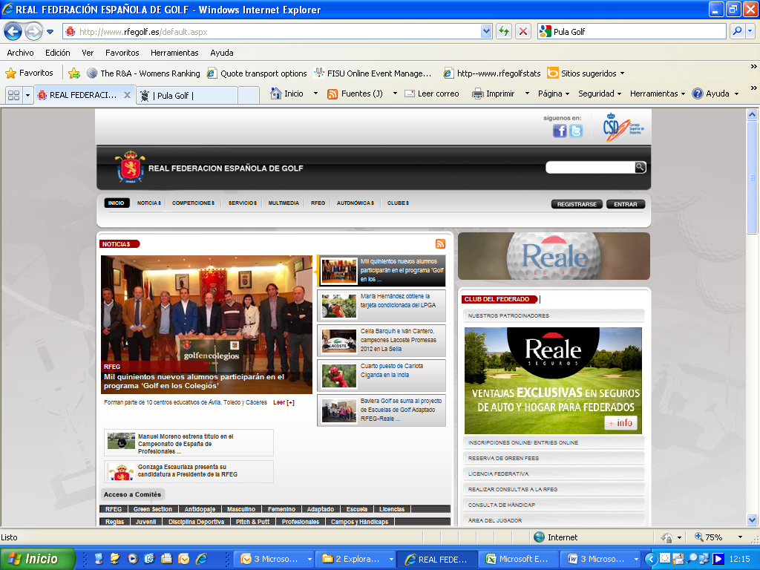

Players should select the competition, click on “ENTRIES ONLINE” and then click on the box: “I am a foreign player” for fill out player’s details.
Players can also require their federation to submit their entry form on their behalf.

Players are responsible to check if their entry form has been accepted.

The entry fee must be paid at registration in the Golf Club. Handicap limit is 6.4.
The list of participants will be published on April 24th at www.rfegolf.es.
Any claims must be submitted within the next 24 hours.

REGISTRATION:
Competitors must register in person at the championship office on site not later tan 12:00 hours on Thursday 9th of May. Telephone calls will be accepted in exceptional circumstances. Players not registered in due time might be substituted by players on the waiting list.

ENTRY FEES:
Entry fees must be paid upon registration:
(The Entry Fee also includes the practice round)

Player fee 60,00 €
Fee for players u-21 30,00 €

CONDITIONS: Find enclosed in page no. 3

CADDIES: Professional golfers are not allowed to caddy.

ELECTRIC TROLLEYS:
The Golf Club has a limited amount of electric trolleys available. Players can book them by phone or email to Las Colinas Golf not later than 23rd of April. Bookings will be awarded on a first come first served basis.

NATIONS CUP:
Attached you will find the appropriate Entry form. National Federations are required to send their team/teams by the closing date.

ACCOMMODATION:

Interested players must return the Accommodation Booking Form (page 4) to HOLEGOLF EVENTOS90 by email, not later than April 23rd.
Confirmations will be sent after the list of participants has been published.

Should you require any additional information, please feel free to contact us on +34 91 555 26 82 or by email, elenavecino@rfegolf.es .

The Royal Spanish Golf Federation looks forward to seeing you in Las Colinas Golf.

CONDITIONS

Eligibility:
Open to all women amateur players who are members of a recognised Golf Union or Federation. Handicap limit is 6.4. The exact handicap certified at date of entry will be used for all purposes. Entries are limited to the 75 competitors with the lowest exact handicap. Entrants tied for the 75th place shall be accepted, if the exceeding number, with that same handicap, were less than the accepted within the 75; otherwise, all entrants holding that handicap will be excluded.
The Women’s Technical Amateur Committee reserves the right to increase the starting field by fifteen invited players.

A minimum of 6 competitors is required for the celebration of the Championship.

Withdrawals must be notified to the Ladies Amateur Technical Committee at the RFEG by 12:00 am, two days before the competition starts. Players who violate this condition will not be able to participate in the next edition of this championship. In addition, they will be obliged to pay the entry fee or they will no longer be able to participate in any RFEG competition until this payment is cleared.

Format:
Three Stroke Play Scratch rounds of 18 holes shall be played. Only players returning the 50 lowest scores over 36 holes shall qualify for final round.

Ties for the Championship title will be decided by a sudden-death play-off over the holes previously established by the Championship Committee. If the holes are not announced, the order will be the stipulated round. Ties for the rest of awarded positions will be solved by card count back using the last 27, 36, 45, 48, 51, 52 and 53 holes; if still a tie, it will be decided by lot.

Entries:
Entry forms shall be submitted to the Royal Spanish Golf Federation by the announced closing date. Entry fees shall be paid upon registration at the Championship venue.

Prizes:
The Champion, second place and third place will receive trophies. A memento will also be given to the best qualified player u-18. Prizes will be non-cumulative.

The Championship Committee reserves the right to alter the format of the Championship in order to achieve a result.

NATIONS CUP

A minimum of one team from five different countries must be registered for the celebration of the Nations Cup. Each team shall consist of two or three players designated by their National Golf Union or Federation. A maximum of two teams per country will be allowed.

Format: Aggregate of the two lowest scores on each of the three Stroke Play rounds. Ties will be resolved by taking into account the aggregate of the non-counting scores; if still tied, the team with the best finished individual player will be proclaimed the winner.

Each member of the winning team will receive a trophy.

All prizes will be donated by The Royal Spanish Golf Federation. No other prizes shall be donated without the Spanish Women Amateur Committee’s

Eventos 90 S.L. Tel. 948 24 10 51 SOLICITUDES POR e-mail/ Requests by email: alfaro@holegolf.com

SPANISH INTERNATIONAL LADIES STROKEPLAY CHAMPIONSHIP

Las Colinas Golf & Country Club. 10 – 12 de mayo de 2013

SOLICITUD DE ALOJAMIENTO / Accommodation request:

DATOS PARA CONFIRMARLES LA SOLICITUD DE ALOJAMIENTO /Details required for guaranteeing your reservation:
Apellidos/Surname: ______________________________________________________Nombre/Name: ____________________

Población/ City: ___________________________________ Telf. Móvil/ Mobile no._________________________________

EMAIL – IMPORTANTE /essential detail:________________________________________________________________________

Telf. / Phone no. _____________________________________ Fax./ Fax no. ____________________________________

Jugadora (1)/ Player 1 _________________________________Jugadora (2)/ Player 2__________________________________

RATES OFFERED ONLY FOR BOOKINGS MADE THROUGH HOLEGOLF EVENTOS90
HOTEL / APARTMENTS | Cat. | BLOQUEO /  No. Of rooms | Habitación  Individual  / Single room  (DUI) | Habitación  Doble  / Twin room | Habitación  Doble + supletoria /  3-bedded room  (80 x 1,90 cm) | Desayuno / Breakfast
LAS COLINAS RESIDENCES  Villas at the golf club  Viviendas en la urbanización del Golf. Totalmente equipados e impecable estado. TV - Wifi.  www.aworldapart.es | High standing | 3 units  (2 dormit./  3 rooms)  3 units  (3 dormit /3 rooms)  3 Villas | Apartamento  2 Dormitorios  2 baños  4 personas /  4 people  112 €/noche  Con IVA | Apartamento  3 Dormitorios  2 baños  6 personas /  6 people  153 €/n.  Con IVA | Villa  3 Dormitorios  2 baños  6 personas /  6 people  172 €/n.  Con IVA | Disponible amplia Oferta en Unik Café en la Casa Club.  Available at the clubhouse
HOTEL GOLF CAMPOAMOR RESORT  En RCG de Campoamor, a unos 3’, en coche, del Golf. 3’ driving to the golfclub  Campo de Golf, Restaurante, cafetería, parking, etc.  Se incluye: piscina indoor, exterior y gimnasio.  http://www.lomasdecampoamor.es/es/hotel/campoamor-i/ | 4  **** | 40 | Habitación  1 persona /1 person  INDIVIDUAL /SINGLE  61 €/noche  DUI  80 €/noche  Con IVA | Habitación  2 personas  TWIN  90 €/n.  Con IVA | Suite  2 baños+2 Dorm  3 personas /3 people  163 €/n.  Suite  2 baños+2 Dorm  4 personas /4 people  203 €/n | INCLUIDO  INCLUDED  BUFFET
HOTEL  MERCURE THALASIA COSTA DE MURCIA  En San Pedro del Pinatar, a unos 15’, en coche, del Golf. 15’ driving to the golfclub. Se incluye acceso a las Piscinas marinas y albornoz. www.thalasia.com | 4  **** | 20 | Habitación  DUI  / 2 BEDS SINGLE USE  1 persona  66 €/noche  Con IVA | Habitación  Doble  2 personas  78 €/n.  Con IVA | Habitación  Doble+suple  3 personas  €/n.  Under request  Con IVA | INCLUIDO  INCLUDED  BUFFET
Precios por habitación y noche. IVA INCLUIDO. DUI: Doble, uso individual. RATES PER ROOM PER NIGHT. VAT INCLUDED

Fecha de llegada /Arrival Date: Fecha de Salida / Departure date:

Habitación individual-DUI/ Single room: Habitación Doble /Twin room:

Apartamento: Nº personas/no pax 2 Dorm/rooms 3 Dorm/ rooms ____ Villa ____

FECHA LÍMITE GARANTIA SOLICITUD: 23 de abril de 2013/ DEADLINE FOR BOOKINGS: April 23rd, 2013
Se confirmará el alojamiento, una vez publicadas las listas de jugadoras admitidas Real Federación Española de Golf
Confirmations will be sent after the list of participants is published

