
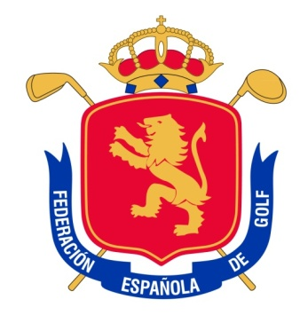


MATCH ESPAÑA vs SUECIA
Arcos Gardens. February 1st & 2nd, 2013

CHAMPIONSHIP PROGRAMME

Thursday January 31st Practice Day
Tee time Sweden: as programmed in their training session.
Tee times for Spain: 09:00 h.

Friday February 1st First competition day
Greensome: Tee-off: 08:30 h., 08:40 h., 08:50h., 09:00. Foursomes: Tee-off: 13:40 h., 13:50 h., 14:00 h, 14:10.

Saturday February 2nd Second and Final competition day
Singles: Tee-off:
09:00 h.
09:08 h.
09:16 h.
09:24 h.
09:32 h.
09:40 h.
09:48 h.
09:56 h.

14:00 h. Prize Giving after lunch with both teams together.

