Emily Pedersen
jgplgp@hotmail.com

Madrid, June 5, 2013

Dear Emily,
As winner of the 2013 Spanish International Ladies Amateur Championship, Copa S.M. La Reina, the Spanish Ladies Amateur Committee has the pleasure to offer you an amateur invitation to participate in the 2013 OPEN DE ESPAÑA FEMENINO.

This LET event will be held from the 18th to the 21st of July 2013 at Club de Villa de Madrid.

Please let us know if you will be able to participate so we can formalize your entry. For any other details, regarding accommodation, practice rounds etc., you may contact the event organizer, Iñigo Aramburu (inigo@deporteandbusiness.com).

We look forward to hearing from you.

Yours sincerely,
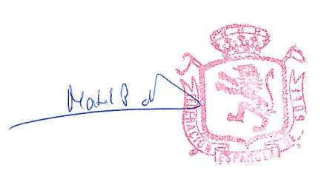

Mabel Pascual del Pobil
Directora Deportiva

