CAMPEONATO NACIONAL DOBLES DE ESPAÑA AMATEUR MASCULINO
Real Club de Golf de La Coruña 15 al 17 de Mayo de 2011

1 | j.juanedA /a.ferrer |  | JOSEP JUANEDA
 |  |  | ANTONI FERRER |  |  | 
32 | BYE |  |  | JOSEP JUANEDA
 |  |  | 13:30 – Tee 1 | ANTONI FERRER
16 | A.MORET / B.OTERO |  | ANDRES MORET | 5/4
 | 08:30 – Tee 1 |  | BRUNO OTERO
17 | F.GRILLO/P. RODRIGUEZ |  | 4/2 |  | JOSEP JUANEDA
 |  |  |  | 08:30 – Tee 1 | ANTONI FERRER
9 | L. FURNELLS / D. TOPS |  | LLUIS FURNELLS |  | 2/1
 |  |  | DAVID TOPS
24 | BYE |  |  | DAVID JIMENEZ
 |  |  | 13:39 – Tee 1 | JAVIER GALLEGOS
8 | D.JIMENEZ/J.GALLEGOS |  | DAVID JIMENEZ | 5/4
 |  |  | JAVIER GALLEGOS
25 | BYE |  |  |  |  | GERMAN HEREDIA
 |  |  |  |  | 13:30 – Tee 1 | MIGUEL DIAZ-NEGRETE
5 | M. GIL / J. SIMON |  | MANUEL GIL |  |  | 3/1
 |  |  | JORGE SIMON
28 | BYE |  |  | MANUEL GIL
 |  |  | 13:48 – Tee 1 | JORGE SIMON
12 | J.MªFDEZ./J.CASTROMIL |  | jOSE Mª FERNÁNDEZ | 6/4
 | 08:39 – Tee 1 |  | JAVIER CASTROMIL
21 | M. BASANTA/J.C.VAZQUEZ |  | 3/1 |  | GERMAN HEREDIA
 |  |  |  | 08:39 – Tee 1 | MIGUEL DIAZ-NEGRETE
13 |  |  | JOAQUIN DE LA RICA |  | 1 UP
 | 08:48 – Tee 1 |  | JORGE COBIAN
20 | J.DE LA RICA/J.COBIAN |  |  | GERMAN HEREDIA
 |  |  | 13:57 – Tee 1 | MIGUEL DIAZ-NEGRETE
4 | G. HEREDIA / M. DIAZ-NEGRETE |  | GERMAN HEREDIA | 6/5
 |  |  | MIGUEL DIAZ-NEGRETE
29 | BYE
 |  |  |  |  |  | 08:30 / 13:30 – Tee 1
3 | A.HORTAL / J.AGUIAR | ANTONIO HORTAL
 |  |  | JAIME AGUIAR
30 | BYE |  |  | ANTONIO HORTAL
 |  |  | 14:06 – Tee 1 | JAIME AGUIAR
14 | A.CASTRO / J.R. CANDA |  | ANGEL CASTRO | 8/7
 | 08:57 – Tee 1 |  | JOSE r. CANDA
19 | P. HERRERO / A. VENDRELL |  | h.19 |  | ANTONIO HORTAL
 |  |  |  | 08:48 – Tee 1 | JAIME AGUIAR
11 | I.ALVAREZ / A. J. LOPEZ |  | IKER ÁLVAREZ |  | 2/1
 |  |  | ALEJANDRO J. LÓPEZ
22 | BYE |  |  | FEDERICO PAEZ
 |  |  | 14:15 – Tee 1 | JOAN GONZALEZ
6 | F. PAEZ / J. GONZALEZ |  | FEDERICO PAEZ | 4/3
 |  |  | JOAN GONZALEZ
27 | BYE |  |  |  |  | ANTONIO HORTAL
 |  |  |  |  | 13:45 – Tee 1 | JAIME AGUIAR
7 | L.BOADO /M.CARBALLAL |  | LUIS BOADO |  |  | 1 UP
 |  |  | MANUEL CARBALLAL
26 | BYE |  |  | LUIS BOADO
 |  |  | 14:24 – Tee 1 | MANUEL CARBALLAL
10 | J.L.SUEIRAS/J.I.SAENZ | JOSE LUIS SUEIRAS |  | 5/4
 |  |  | JUAN IGNACIO SAENZ
23 | BYE |  |  |  | LUIS BOADO
 |  |  |  | 08:57 – Tee 1 | MANUEL CARBALLAL
15 | J. TOME / F.N. JEMEZ |  | JORGE TOMÉ |  | 1 UP
 | 09:06 – Tee 1 |  | FRANCISCO JEMEZ |  |  | 
18 | R. RUA / L. LOPEZ |  | 7/6 | ALBERTO FERNANDEZ
 |  |  | 14:33 – Tee 1 | HUGO MENENDEZ |  |  | 
2 | A.FDEZ./H.MENENDEZ |  | ALBERTO FERNANDEZ | 2 UP
 |  |  | HUGO MENENDEZ
31 | BYE
 | 1/16 Final |  | 1/8 Final | 1/4 Final | 1/2 Final | Final | CAMPEONES
15 de mayo 16 de mayo 17 de mayo

CAMPEONATO NACIONAL DOBLES DE ESPAÑA MASCULINO
Real Club de Golf La Coruña 15 al 17 de Mayo de 2011

DESARROLLO de la FINAL

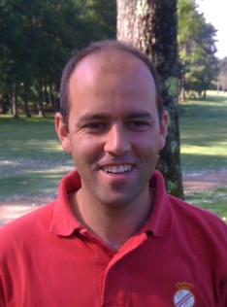 | 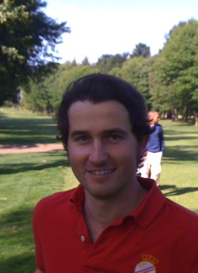  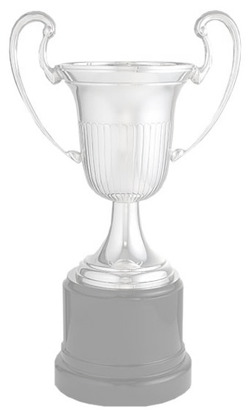 |  | 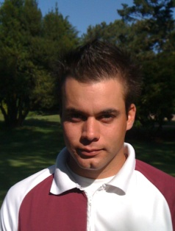 | 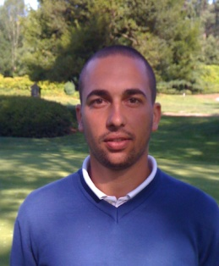

M. DIAZ NEGRETE | GERMAN HEREDIA |  | ANTONIO HORTAL | JAIME AGUIAR

HOYO | 1 | 2 | 3 | 4 | 5 | 6 | 7 | 8 | 9 | 10 | 11 | 12 | 13 | 14 | 15 | 16 | 17 | 18
PAR | 3 | 5 | 4 | 4 | 4 | 5 | 3 | 4 | 4 | 4 | 3 | 4 | 5 | 3 | 4 | 4 | 5 | 4
M. DIAZ NEGRETE
GERMAN HEREDIA
ANTONIO HORTAL
JAIME AGUIAR
RESULTADO

HOYO | 1 | 2 | 3 | 4 | 5 | 6 | 7 | 8 | 9 | 10 | 11 | 12 | 13 | 14 | 15 | 16 | 17 | 18
PAR | 3 | 5 | 4 | 4 | 4 | 5 | 3 | 4 | 4 | 4 | 3 | 4 | 5 | 3 | 4 | 4 | 5 | 4
M. DIAZ NEGRETE
GERMAN HEREDIA
ANTONIO HORTAL
JAIME AGUIAR
RESULTADO

