On behalf of La Real Sociedad de Golf de Neguri, I would like to extend my warm welcome to all officials and players visiting us for the Jacques Leglise Trophy, and the Royal Spanish Golf Federation, and his President, Gonzaga Escauriaza, member of our club, in the year we celebrate our Centenary.

We have done our best to present the course and facilities in perfect conditions so that you all enjoy your stay, and playing in La Galea. A course designed by Javier Arana on the early 60’s, that has hosted, together with this Jacques Leglise Trophy, three amateur matches between Great Britain&Ireland and Continental Europe.

I want to thank the R&A and the EGA for giving us the opportunity to host in our Club such an important event. We have worked with enthusiasm and passion to deliver a great sporting event, and we hope that you will all have a great time in Neguri and enjoy of excellent golf.

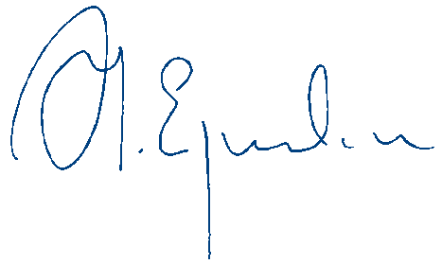
I wish you all a memorable and successful match, and I am certain that all spectators and members of our club will enjoy watching you play. I wish you all best of luck!

Alfonso Eguidazu
President
Real Sociedad de Golf de Neguri

