

VENUE

Real Sociedad de Golf de Neguri
Apartado 9 – 48990 – Algorta - Getxo Vizcaya
Tel. +34.94 491 02 00 - Fax +34.94 460 56 11
Web site: www.www.rsgolfneguri.com mail address: rsgn@rsgolfneguri.com

COURSE
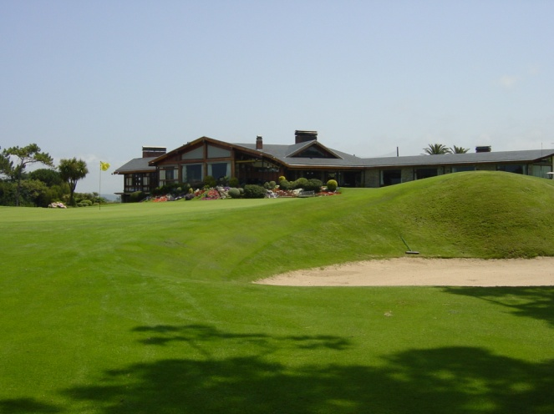
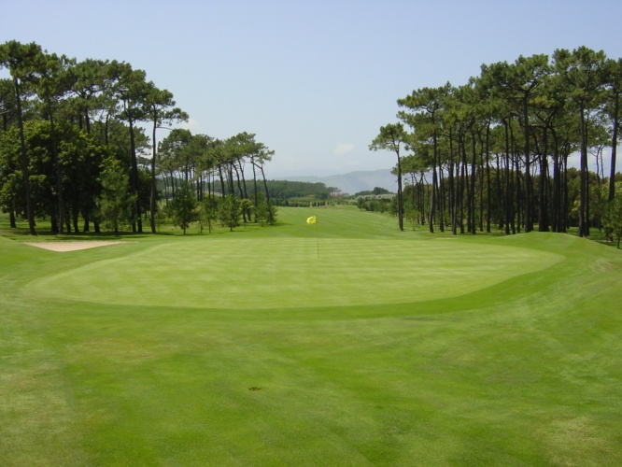

Neguri, or Real Sociedad de Golf de Neguri to give the club its full title, was originally founded way back in 1911 and the original course was an 11- hole affair located in Lejona. Fifty years later, the club moved to its present site in Getxo, Punta Galea, to the north west of Bilbao.
Spanish architect Javier Arana – who went on to design many fine Iberian courses like Guadalmina Sur in 1965, and El Saler in 1968 – designed the new 18-hole course, and Neguri is considered to be one of his best creations.
Measuring 6,900 yards from the championship tees, the course is laid out in two loops of nine, that both end close to the clubhouse. It is a golfing layout for the connoisseur, with wide fairways, enormous greens and minimal greenside bunkering.
Some of the holes on the property sit along the cliff tops, two hundred feet above sea level, and there are fine vistas of the Cantabrian Sea to be glimpsed through the trees.
One of the best holes on the course is the 211-yard, par three 14th which is played uphill to a green protected by a single bunker – but what an intimidating sand trap that solitary hazard is, with its steep face visible from the tee, sitting right in front of the raised putting surface.
Visitors must play the course with a member, but Neguri have a reciprocal arrangement with many Spanish clubs to allow their members courtesy of the course.
R.S.G. NEGURI SCORE CARD
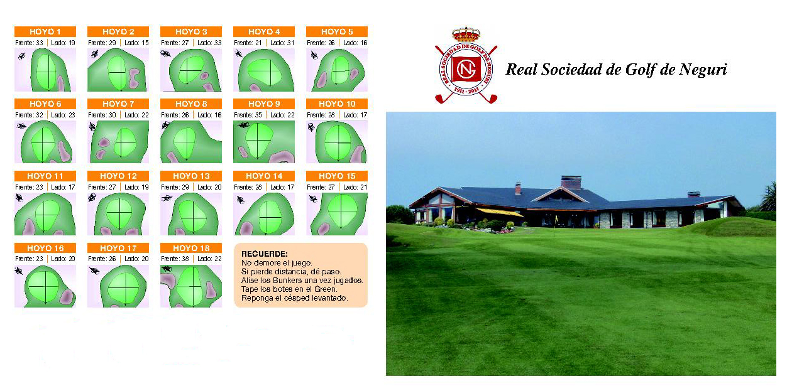



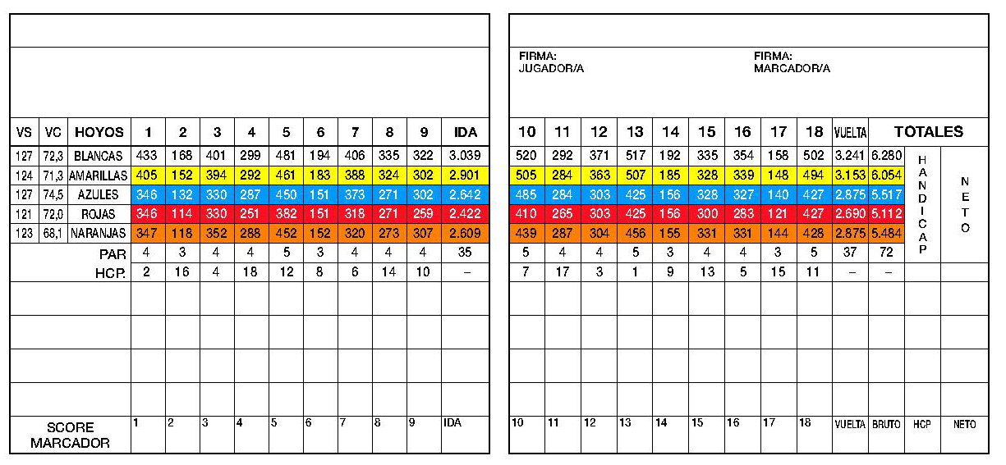

OFFICIAL HOTELS
HOTEL HIGH TEC – TAMARISES GETXO ***
Muelle de Ereaga, nº4
48992 Getxo – Algorta (Bizkaia)
tel: +34 944 915 092
fax: +34 944 601 991
E – mail: tam@hthoteles.com
(25 rooms are available . Reserved for Teams and Officials)
15 Rooms with seafront view:
Single Room: 115,00 € + 8% VAT
Twin Room: 120,00 € + 8% VAT
10 Rooms without seafront view:
Single Room: 95,00 € + 8% VAT
Twin Room: 100,00 € + 8% VAT
In all cases Buffet Breakfast is included.

HOTEL NH La Avanzada ****
Paseo Landabarri, 5.
48940 Leioa. Bilbao (España)
Tel. 94 464 0194 Fax: 94 480 7523
E- mail: nhlaavanzada@nh-hotels.com
(20 Rooms are available)
20 Rooms:
Single Room:70,00 € + 8% VAT (*)
Twin Room: 80,00 € + 8% VAT (*)
(*) - including buffet breakfast.

AIRPORT

The official Airport is Bilbao Airport
It is a public airport located 9 km (5.6 mi) north of Bilbao, in the municipality of Loiu, in the Basque Country. It is the most important airport of the Basque Country and northern Spain, with 4,172,903 passengers on 2008 (declined by 2.7% compared to 2007). It is famous for its new main terminal opened in 2000 and designed by Santiago Calatrava.
TRANSPORTATION

The Royal Spanish Federation Will provide transport for both teams and officials from the Airport – Hotel – Airport and Hotel – Golf course – Hotel.

Distance: Hotel/Golf Club: 8km, about 15 min.

MEALS

At the club restaurant.
A Sport Set Menu will be available every day for players at a Price of 15,00 €.at the snack bar where each team will have table allocated. All type of sandwiches and Spanish tapas will also be available.

Each Team will have a tab where they can charge all their expenses and orders and will be paid at the end of the match.

Also a la carte menu, with a big choice of dishes, will be available at the main restaurant. Please notice that golf shoes, short pants and waterproofs will not be allowed.

CREDIT CARDS

All major credit cards are accepted at the hotel and at the Golf Club.

PRESS ROOM

Press Area will be at disposal of media representatives in the Tournament office.

MEDICAL SERVICE

An ambulance will be attending on practice and tournament days

TROLLEYS

Trolleys will be available for all teams. Electric trolleys not available.

LOCKERS

Lockers will be reserved for players and officials.

REFEREES

A referee shall be appointed to each match. The Royal Spanish Golf Federation shall provide a Chief Referee and sufficient number of referees, but as usual R&A and EGA Officials attending the event, who wish to referee, are very welcome. They will be asked to referee one match daily (walking referee). We kindly invite you to inform us by filling the attached Officials form.

OPENING CEREMONY

The Opening Ceremony will take place at R.S.G. Neguri Golf Club at 7.30pm on Thursday 25th August. It will be followed by Welcome Cocktail for players, officials and guests.

GOLF COMPETITION FOR OFFICIALS

The Officials’ and guests competition will take place at Real Sociedad de Golf de Neguri, venue Jacques Leglise Trophy, on Thursday 25th August (See enclosure B). .

Tee times and the starting list will be announced the eve at the Hotel and posted in the information board at the golf club.

DINNER FOR OFFICIALS AND GUESTS

The dinner for officials and guests, offered by the Royal Spanish Golf Federation, will take place at the Club Maritimo on Friday 27th August at 8.00pm. Transfers will be by car and will depart at 7:30 pm from the hotel (See enclosure C)

CLOSING CEREMONY

Closing Ceremony will take place the R.S.G. Neguri and will be followed by a Farewell Dinner-Party.

PROGRAMME

Tuesday 23rd August
▪ All day Teams’ arrival
▪ 18:30 – 19:30 Teams registration (at the hotel)
▪ Evening Free for teams and officials

Wednesday 24th August
▪ 7:30 – Teams transport to the Golf Course
▪ From 09:00 First official practice day
▪ Evening Free for teams and officials

Thursday 25th August
▪ 7:30 – Teams transport to the Golf Course
▪ From 9:00 Second official practice day
▪ 8:15 Departure from the hotel for officials and guests playing the Duffers Competition
▪ 9:30 Tournament for officials and guests at the Golf Club
▪ 18:00 Captains meeting (at R.S.G Neguri)
▪ 19:00 Official team photographs (at R.S.G Neguri)
▪ 19:30 Opening Ceremony (at R.S.G Neguri) followed by Welcome Cocktail for players and officials

Friday 26th August

▪ 7:15 – Teams transport to the Golf Course
- 8:15 - Departure from the hotel for officials and guests.
- 8:30 – 9:00 Foursomes
▪ 13:30 – 14:40 Singles
▪ 19:30 - Officials Dinner offered by the RFEG – Club Marítimo
▪ Evening Free for players

Saturday 27th August

- 7:15 – Teams transport to the Golf Course
- 8:15 - Departure from the hotel for officials and guests.
▪ 8:30 – 9:00 Foursomes (departures from 1 and 10)
▪ 13:30 – 14:40 Singles
▪ 19:00 Prize presentation and Closing Ceremony Followed by Farewell Dinner-Party (at R.S.G Neguri)

Sunday 28th August
▪ All day, Teams, officials and guests departure.

TEAMS TRAVELLING FORM - Arrival

TEAM _______________________________________

Date of arrival_____________________ Airport __________________________

Time ____________________________ Flight ___________________________

Coming from: _________________________________________________________

Name Player/Captain/Other
________________________________ _______________________________
________________________________ _______________________________
________________________________ _______________________________
________________________________ _______________________________
________________________________ _______________________________
________________________________ _______________________________
________________________________ _______________________________
________________________________ _______________________________
________________________________ _______________________________
_______________________________ _______________________________
________________________________ _______________________________

Single arrivals
Name Player/Captain/Other
________________________________ ________________________________

Date of arrival_____________________ Airport __________________________

Time ____________________________ Flight ___________________________

Coming from: _________________________________________________________

Special requirements: __________________________________________________ ____________________________________________________________________

Name Player/Captain/Other
________________________________ ________________________________

Date of arrival_____________________ Airport __________________________

Time ____________________________ Flight ___________________________

Coming from: _________________________________________________________

Special requirements: __________________________________________________

Contact person

Name & mobile phone___________________________________________________

Date ____________________________ Signature________________________

TEAMS TRAVELLING FORM - Departure

TEAM _______________________________________

Date of arrival_____________________ Airport __________________________

Time ____________________________ Flight ___________________________

Coming from: _________________________________________________________

Name Player/Captain/Other
________________________________ _______________________________
________________________________ _______________________________
________________________________ _______________________________
________________________________ _______________________________
________________________________ _______________________________
________________________________ _______________________________
________________________________ _______________________________
________________________________ _______________________________
________________________________ _______________________________
_______________________________ _______________________________
________________________________ _______________________________

Single arrivals
Name Player/Captain/Other
________________________________ ________________________________

Date of arrival_____________________ Airport __________________________

Time ____________________________ Flight ___________________________

Coming from: _________________________________________________________

Special requirements: __________________________________________________ ____________________________________________________________________

Name Player/Captain/Other
________________________________ ________________________________

Date of arrival_____________________ Airport __________________________

Time ____________________________ Flight ___________________________

Coming from: _________________________________________________________

Special requirements: __________________________________________________

Contact person

Name & mobile phone___________________________________________________

Date ____________________________ Signature________________________

TEAMS OFFICIALS FORM

Name_________________________________________________

Organisation & function ________________________________________

Accompanied by_____________________________________________

Travel details

Date of arrival_____________________ Airport _________________________

Time ____________________________ Flight _________________________

Coming from: ______________________________________________________

Date of departure___________________ Airport _________________________

Time ____________________________ Flight _________________________

Special requirements:________________________________________________
__________________________________________________________________

Accommodation

IN ______________________________ OUT___________________________

Double room □ Twin room □ Single room □

Room payment Organisation □ Self payer □

Referees

Do you wish to referee the match? Yes □ No □

Duffers Competition

Would you like to play the Duffers Competition on the 25th August? Yes □ No □ - Handicap:______

Special food requirements (allergies) for official lunch/dinners
_________________________________________________________________

Remarks_____________________________________________________________________________

______________________________________________

_______________________________________________________________

Date____________________________ Signature_______________________

TEAM COMPOSITION

ORGANISATION _______________________________

Players names (Block letters please)

Nº | NAME | COUNTRY

CAPTAIN: ……………………………………………………………………….

Others / Officials:
_______________________________________________________________
Nº | NAME | COUNTRY

Date & Signature ____________________

