CARATULA DE FAX

PARA / TO: Premier Inn Epson South

DE / FROM: Mr. Jorge Sagardoy Fidalgo

FECHA / DATE: 7th June 2012

Nº FAX/ FAX: + 44 871 48278383 Nº PAG/ PAGES: 1

Dear Sirs:
According to our telephone conversation we want to confirm our booking ref: AJJR87423, with 3 twin Rooms + 1 single room, arriving on the 25th June and Departing the 2nd July 2012.

We would like to charge the whole invoice in the following credit card.

Type: VISA
Number: 4546 5302 4070 7959
Exp: 05 / 2015
Holder: JORGE SAGARDOY FIDALGO.

Regarding our group, Mr Yago Beamonte will be the manager and he will collect the invoice and the visa charge receipts upon his arrival the 25th June.

If you need any further information, please you can contact:
Mr. Ernesto Fernandez de Gamboa
E mail: efgamboa@rfegof.es – mobile phone. +34 630 088 055.

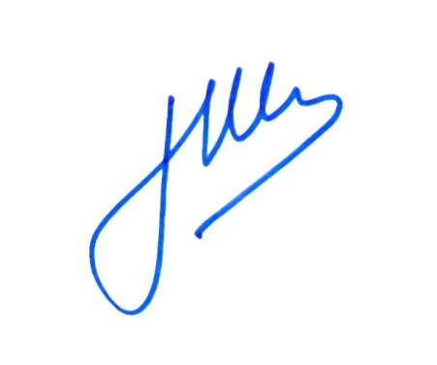
Looking Forward to hearing from you.

Best Regards.

Jorge Sagardoy Fidalgo
Director General
REAL FEDERACION ESPAÑOLA DE GOLF
c/ Arroyo del Monte, 5 • 28035 Madrid
T. (+34) 91 376 91 30 • F. (+34) 91 556 32 90
rfegolf@rfegolf.es • www.rfegolf.es

