CARATULA DE FAX

PARA / TO: Premier Inn Mansfield

DE / FROM: Mr. Jorge Sagardoy Fidalgo

FECHA / DATE: 16th June 2012

Nº FAX/ FAX: + 44 871 527 8759 Nº PAG/ PAGES: 1

Dear Sirs:
According to our telephone conversation we want to confirm our booking ref: ALJR186214, with 5 twin Rooms + 3 single rooms, arriving on the 11th August and Departing the 17th August 2012.

We would like to charge the whole invoice in the following credit card.

Type: VISA
Number: 4546 5302 4070 7959
Exp: 05 / 2015
Holder: JORGE SAGARDOY FIDALGO.

Regarding our group, Mr Francisco Parron will be the manager and he will collect the invoice and the visa charge receipts upon his arrival the 11th August.

If you need any further information, please you can contact:
Mr. Ernesto Fernandez de Gamboa
E mail: efgamboa@rfegof.es – mobile phone. +34 630 088 055.

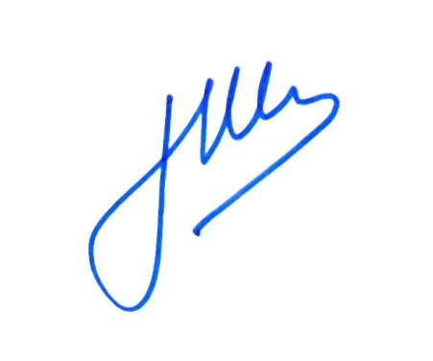
Looking Forward to hearing from you.

Best Regards.

Jorge Sagardoy Fidalgo
Director General
REAL FEDERACION ESPAÑOLA DE GOLF
c/ Arroyo del Monte, 5 • 28035 Madrid
T. (+34) 91 376 91 30 • F. (+34) 91 556 32 90
rfegolf@rfegolf.es • www.rfegolf.es

