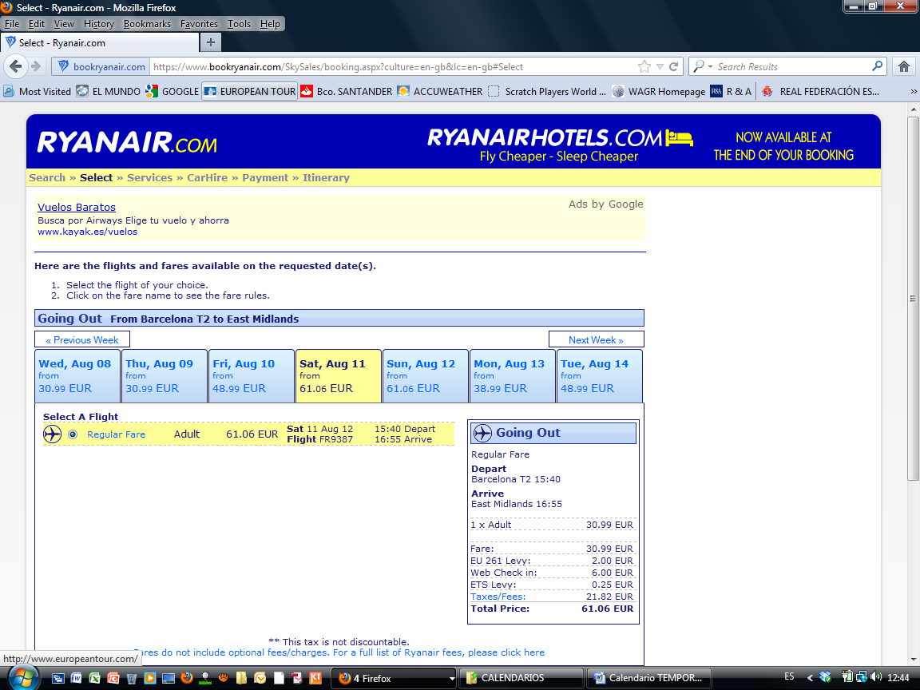

DUBLIN – EAST MIDLANDS (RAHM y GALIANO)
