Madrid – Dublin – Air Lingus

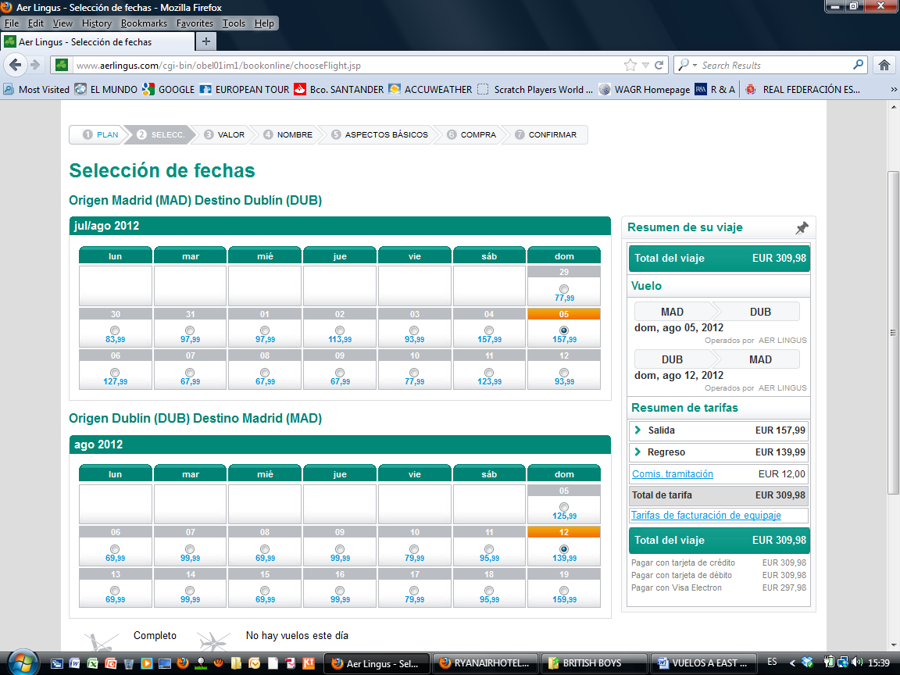
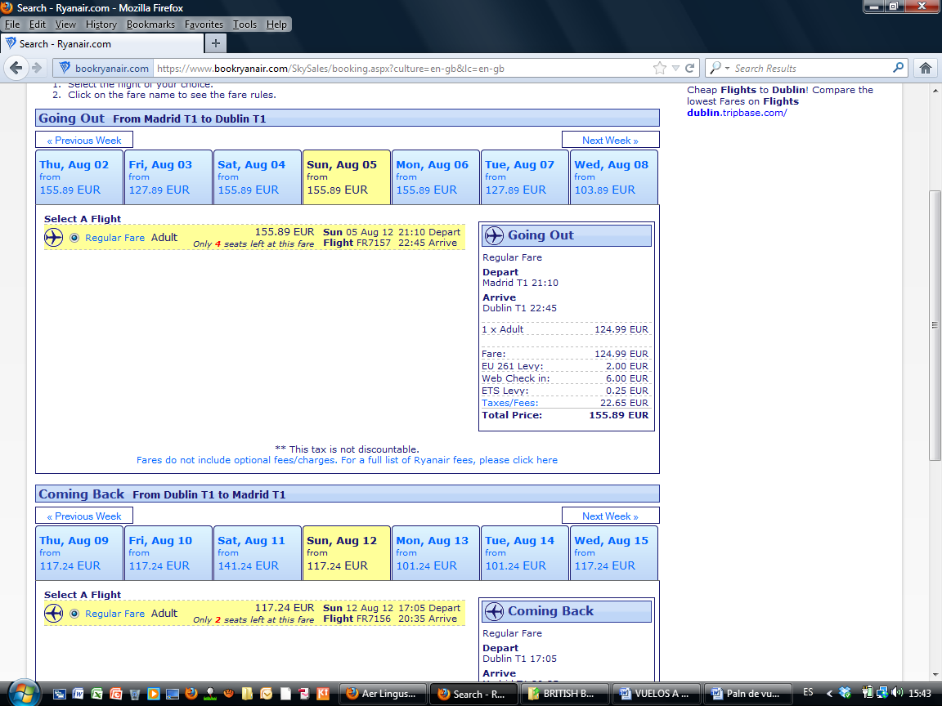
Vuelos Ryanair – Madrid – Dublin - madrid

Barcelona – Dublin - Barcelona
