


REAL FEDERACIÓN ESPAÑOLA DE GOLF

C/ Arroyo del Monte, 5 - 28049 MADRID - T: (34) 91 376 91 30 - F: (34) 91 556 32 90 - rfegolf@rfegolf.es - www.rfegolf.es

SPANISH INTERNATIONAL U-18 (BOYS) STROKE PLAY CHAMPIONSHIP
Hacienda del Álamo Golf Resort. 4 - 7 September 2014


– Counting Event for the R&A World Amateur Golf Ranking –

GOLF COURSE: HACIENDA DEL ÁLAMO GOLF RESORT
Avda. Hacienda Del Álamo, 11
30320 Fuente Álamo
Murcia, España
Tel.: (+34) 968 157 236
E-mail: golfers@hdagolf.com
http://www.clubdegolfhda.com

DATES: 4th to 7th September 2014
Official Practice Day: 3th September 2014.
(To reserve practice times, please contact to Hacienda del Álamo Golf directly)

LOCATION: http://www.clubdegolfhda.com/ubicacion

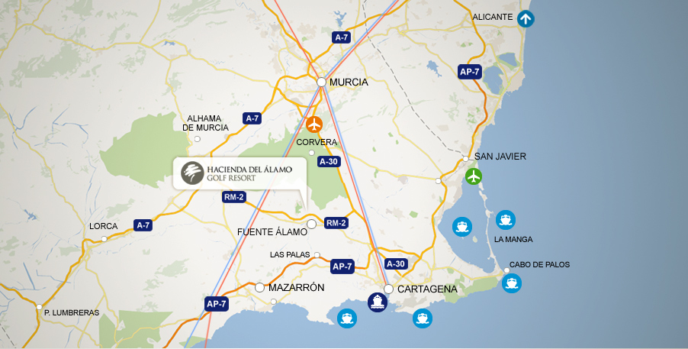

ENTRIES: Entries must be submitted ONLINE http://www.rfegolf.es by 23:59 hours, August 25th, 2014. Entries failing this condition will not be accepted.

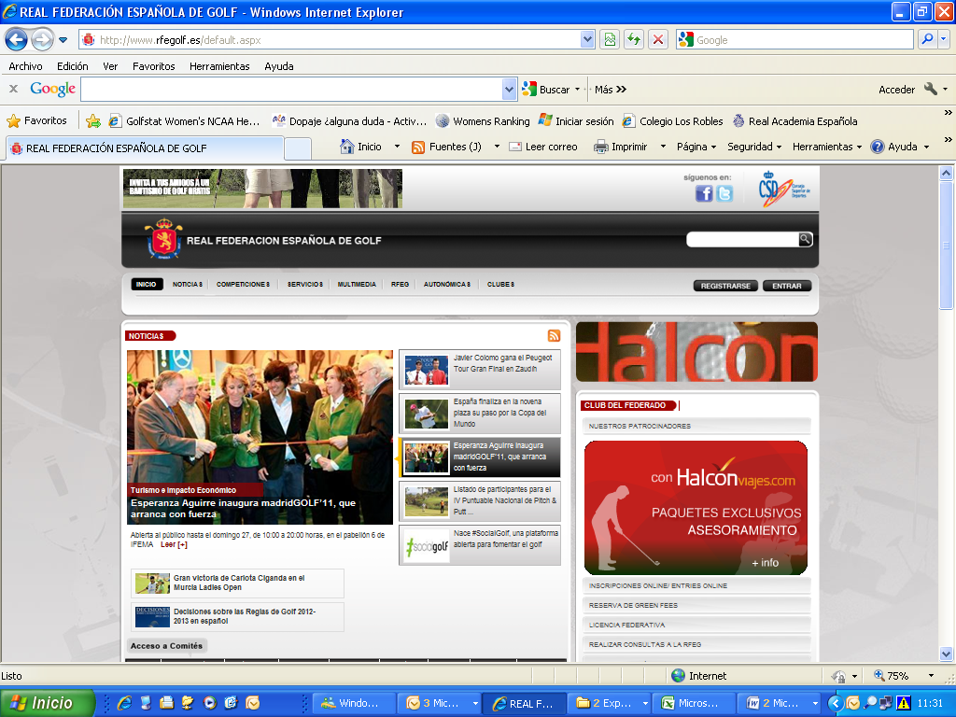

Players should select the competition, click on “entries online”
After that, player must click on the box: “I am a foreign player” and fills player’s details required for the competition.

You can also require your federation to submit your entry form on your behalf. Players are responsible to check if her entry form is accepted. Any claims must be submitted within the next 24 hours after the list of participants is published.

For Spanish Players, the official exact handicap to make the list of accepted players will be listed in the database of the RFEG at 10:00 a.m. the day after the closing date. For Foreign Players, the official exact handicap used for all purposes will be the certified handicap at date of entry by their National Golf Federation, Union or Association.

The list of accepted teams and the waiting list (if any) will be published at the web site of the Royal Spanish Golf Federation (www.rfegolf.es) from the day after the closing date.

ENTRY FEES: Entry fees should be paid upon arrival at the club house of Hacienda del Álamo:

- Under 18 & 16 Players……………………… 60, 00 €
(Born between 1996 and 1999)

- Under 14 Players……………..………..…….. 30, 00 €
(Born in 2000 or later)

REGISTER
OF PLAYERS: The register of players and the pay of the entry fee will be made in the golf club jointly, within the time and place established by the Championship Committee (on the official practice day preferably). Players who cannot go the club on the official practice day and, as such, cannot register and pay the fee by the deadline, should contact the secretary of the club or the tournament direction to confirm their participation in the championship conclusively. Failure to do so, the Championship Committee may replace the player for the appropriate waiting list (if any).

CONDITIONS: Open to all Spanish Player or Foreign Men Amateurs born after January 1st 1996 with an exact handicap maximum of 6,0 (the championship conditions is enclosed to this information).

ACCOMMODATION
OFFER:

- APARTMENTS AND VILLAS

All reservations you choose must be made through HOLE GOLF – EVENTOS 90 S.L., before AUGUST 22th 2014 by filling in the accommodation booking form that we herewith enclose. You must send it by e-mail to:

HOLE GOLF – EVENTOS 90 S.L.
(Att.: Mr. Íñigo Alfaro)

APPLICATIONS BY E-MAIL: alfaro@holegolf.com
Tel.: +34 948 24 10 51

SPANISH INTERNATIONAL UNDER 18 (BOYS) STROKE PLAY CHAMPIONSHIP

Counting Event for the R&A World Amateur Golf Ranking

CONDITIONS

ELIGIBILITY:

Any amateur player born after January 1st 1996, with an exact handicap of 6.0 or better, in possession of their National Federation or Union Membership Card is eligible to enter. All entries will be subject to the approval of the Championship Committee which reserves the right to accept or refuse, or having accepted, subsequently reject any entry without giving reason for its decision.

Entries are limited to 90 competitors. If the number of entries exceeds these, the high-handicap players will be eliminated from the championship by draw.

For Spanish Players, the official exact handicap to make the list of accepted players will be listed in the database of the RFEG at 10:00 a.m. the day after the closing date. For foreign players, the official exact handicap used for all purposes will be the handicap certified at date of entry for their National Golf Federation, Union or Association.

If, for any reason, a competitor is unable to participate, he must communicate this to either the Championship Committee at the Club or to the Amateur Technical Committee or the Royal Spanish Golf Federation before 12:00 a.m. of two days before the starting of the championship. Any player who fails to follow this procedure risks having his entry refuses for the following year’s edition.

Unsuccessful entrants will be informed immediately after the closing date and will be placed on a reserve list, by exact handicap order, and given the opportunity to compete if there are subsequent withdrawals. The possible absences reported in the specified period will be covered one by one. The criteria used for establishing priorities among players with the same exact handicap on the reserve list will be the earliest date of entering.

The register of players and the pay of the entry fee will be made in the golf club jointly, within the time and place established by the Championship Committee (on the official practice day preferably). Players who can not go the club on the official practice day and, as such, can not register and pay the fee by the deadline, should contact the secretary of the club or the tournament direction to confirm their participation in the championship conclusively. Failure to do so, the Championship Committee may replace the player for the appropriate waiting list (if any).

FORMAT:

Over four rounds of 18 holes stroke play scratch each day (72 holes from white marks). After the 3rd round, a cut will be established. The first 50 qualified players and ties will qualify for the 4th round.

In the event of a tie for the first place, the winner shall be decided by a sudden death play-off. The championship committee will lay down the order of the holes to play. If it is not fixed, the natural order will prevail. The runner-up trophy will be awarded to the highest playing handicap player.

If for any reason, any representative of the U-16 scratch category does not qualify for the 4th round, the prize for that given category will be according with the 3rd round classification.

Caddies will not be allowed.

NOTE: The Championship Committee reserves the right to amend the championship conditions.

ENTRIES:

Entries must be submitted ONLINE (www.rfegolf.es). The closing date and the entry fee will be determined by the Royal Spanish Golf Federation each year. The entry fee should be paid upon arrival at the Golf Club, before the championship.

STARTING TIMES:

The Amateur Committee of the Royal Spanish Golf Federation will establish the order and the starting times for each round.

PRIZES:

The Royal Spanish Golf Federation will offer trophies to the scratch champion, scratch runner-up and to the scratch third placed. The first scratch under-16 player placed will receive trophy too.

To compete in a category, must have a minimum of six players participating.

THE PRIZES WILL BE ACCUMULATIVE.

No more prizes may be submitted without the agreement of the Amateur Committee of the Royal Spanish Golf Federation.

NATIONS CUP:

To play the trophy, must have a minimum of 3 Nations represented. The Nations Cup will be played simultaneously with the first 3 Stroke Play rounds only (54 holes) by National Teams designated by their National Golf Union or Federation. Two or three players will compose these teams. The two best scores each day will count.

In the event of a draw, those three scores not previously counted will be taken into account and the team with the lowest score will win. If the draw persists, the team with the lowest individual score will be proclaimed winner. The winning team will receive a trophy.


Eventos 90 S.L.
Pamplona
Tel. (+34) 948 24 10 51
APPLICATIONS BY E-MAIL: alfaro@holegolf.com

SPANISH INTERNATIONAL U-18 (BOYS) STROKE PLAY CHAMPIONSHIP

Hacienda del Álamo G.C. 4th to 7th September 2014

ACCOMMODATION BOOKING FORM

DETAILS FOR THE CONFIRMATION: YOU MUST SEND BY E-MAIL TO: alfaro@holegolf.com

Surname: |  | Name
Passport Nº |  | Mobile Nº:
Country | Telephone:
E-mail (IMPORTANT):
Player (1)
Player (2)

ESTABLISHMENT | Cat. | BLOCK | APARTMENTS | VILLA | VILLA | Breakfast
APARTAMENTOS AND VILLAS  Golf Hacienda del Álamo  4 NIGTHS, minimum  www.home-kare.com |  | 2 rooms  30  3 rooms.  10 | APARTMENTS  2 rooms 3-4 beds + 2 bathrooms  3-4 people  100 €/night  Vat included | VILLA  2 rooms 3-4 beds + 2 bathrooms  3-4 people  115 €/night  VAT included | VILLA  3 rooms 5-6 beds + 3 bathrooms  5-6 people  135 €/night.  VAT included | NO  Possibility in the Golf Club

ALSO WE CAN OFFER HOTELS FROM 25-30 MINUTES BY CAR

ACCOMMODATION REQUERIMENTS

Arrival Date Departure Date Departure according to the cut

2 PEOPLE: 3 PEOPLE: 4 PEOPLE: 5 PEOPLE 6 PEOPLE:

Please return this form not later than 22 AUGUST 2014 to: alfaro@holegolf.com

