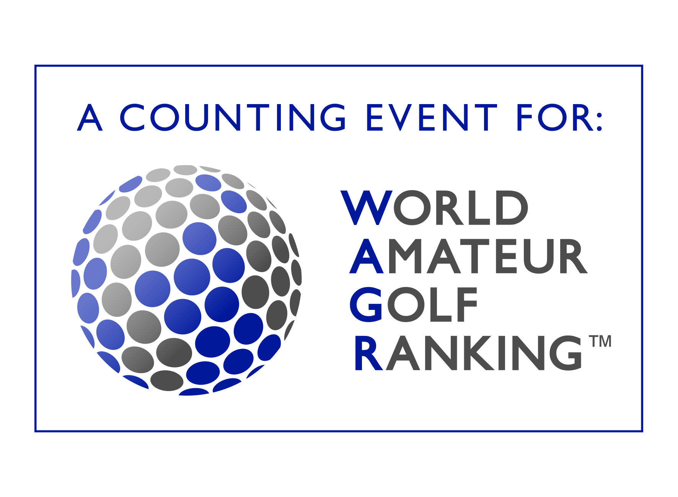

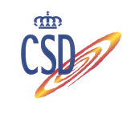

CAMPEONATO INTERNACIONAL AMATEUR DE ESPAÑA MASCULINO
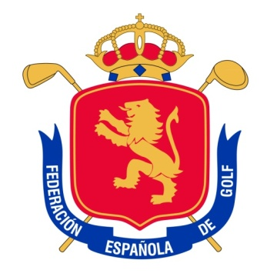
SPANISH INTERNATIONAL AMATEUR CHAMPIONSHIP
“Copa S.M. El Rey”
Sherry Golf. 25 February -1 March 2015

COMITÉ DE LA PRUEBA / CHAMPIONSHIP COMMITTEE

D. PABLO FISAS AYXELÁ
Vocal del Comité Técnico Amateur Masculino de la R.F.E.G.
Member of the Amateur Committee of the Royal Spanish Golf Federation

D. JOSÉ MIGUEL SAGNIER RIERA
Vocal del Comité Técnico Amateur Masculino de la R.F.E.G.
Member of the Amateur Committee of the Royal Spanish Golf Federation

D. ASÍS DE BASTIDA ZUBIRÍA
Vocal del Comité Técnico Amateur Masculino de la R.F.E.G.
Member of the Amateur Committee of the Royal Spanish Golf Federation

D. CARLOS DE CORRAL ALDECOA
Vocal del Comité Técnico Amateur Masculino de la R.F.E.G.
Member of the Amateur Committee of the Royal Spanish Golf Federation

D. AGUSTÍN MAZARRASA DÍAZ DE BUSTAMANTE
Vocal del Comité Técnico Amateur Masculino de la R.F.E.G.
Member of the Amateur Committee of the Royal Spanish Golf Federation

D. EMILIO LUSTAU
Director Gerente de Sherry Golf
Manager Director of Sherry Golf

D. ERNESTO FERNÁNDEZ DE GAMBOA(Director del Torneo)
Director Deportivo de la Real Federación Española de Golf.
Sport Manager of the Royal Spanish Golf Federation

CAMPEONATO INTERNACIONAL AMATEUR DE ESPAÑA MASCULINO
SPANISH INTERNATIONAL AMATEUR CHAMPIONSHIP
“Copa S.M. El Rey”
Sherry Golf. 25 February -1 March 2015

ÁRBITROS / Referees

D. PABLO CHAVES PUCH (Principal/ Chief Referee)
D. XAVIER BURJACHS ALADRÉN
D. FERNANDO PASCUAL DEL POBIL OCA
D. JAIME ORDOVÁS ARTIEDA

