



CAMPEONATO INTERNACIONAL AMATEUR DE ESPAÑA MASCULINO
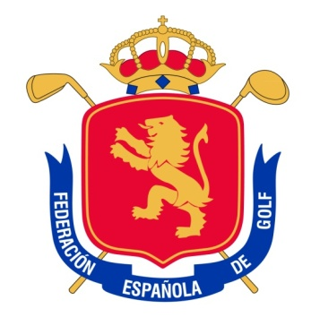
SPANISH INTERNATIONAL AMATEUR CHAMPIONSHIP
“Copa S.M. El Rey”
Sherry Golf. 25 February -1 March 2015
CHAMPIONSHIP PROGRAMME

February 23th: First Practice day
Players registration (upon arrival at the Clubhouse), before 12:00 hours.
(To reserve practice time, please contact the Golf Club directly)
All players on the waiting list should report to the Championship office

February 24th: Second Practice day
Confirmation of Teams for NATION´S CUP
(Must be received before 16:00 hrs.)

17:00 hrs.: All players in waiting list should go to the Championship office in order to check any available spots.

February 25th: First competition day. 18 holes Stroke Play..........................Tees 1 and 10

February 26th: Second competition day. 18 holes Stroke Play......................Tees 1 and 10

February 27th: Third competition day. Match Play
08:15h. – 09:11h.: First Match Play round (1/16 final).......Tees 1 and 10
13:15h. – 14:00h.: Second Match Play round (1/8 final)…..Tees 1 and 10

February 28th: Fourth competition day. Match Play
08:15h. – 09:11h.: Third Match Play round (1/4 final)...................Tee 1
13:15h. – 14:00h.: Fourth Match Play round (semi-finals).............Tee 1

March 1st: Fifth competition day. Match Play
08:30h. – 13:30h.: Final (36 holes)
18:00h. (approx.): Prize Giving Ceremony

