European Boys' Team Championship - Jean-Louis Dupont Trophy
Pickala Golf, Finland
07/07/2015 - 11/07/2015

FLIGHT A

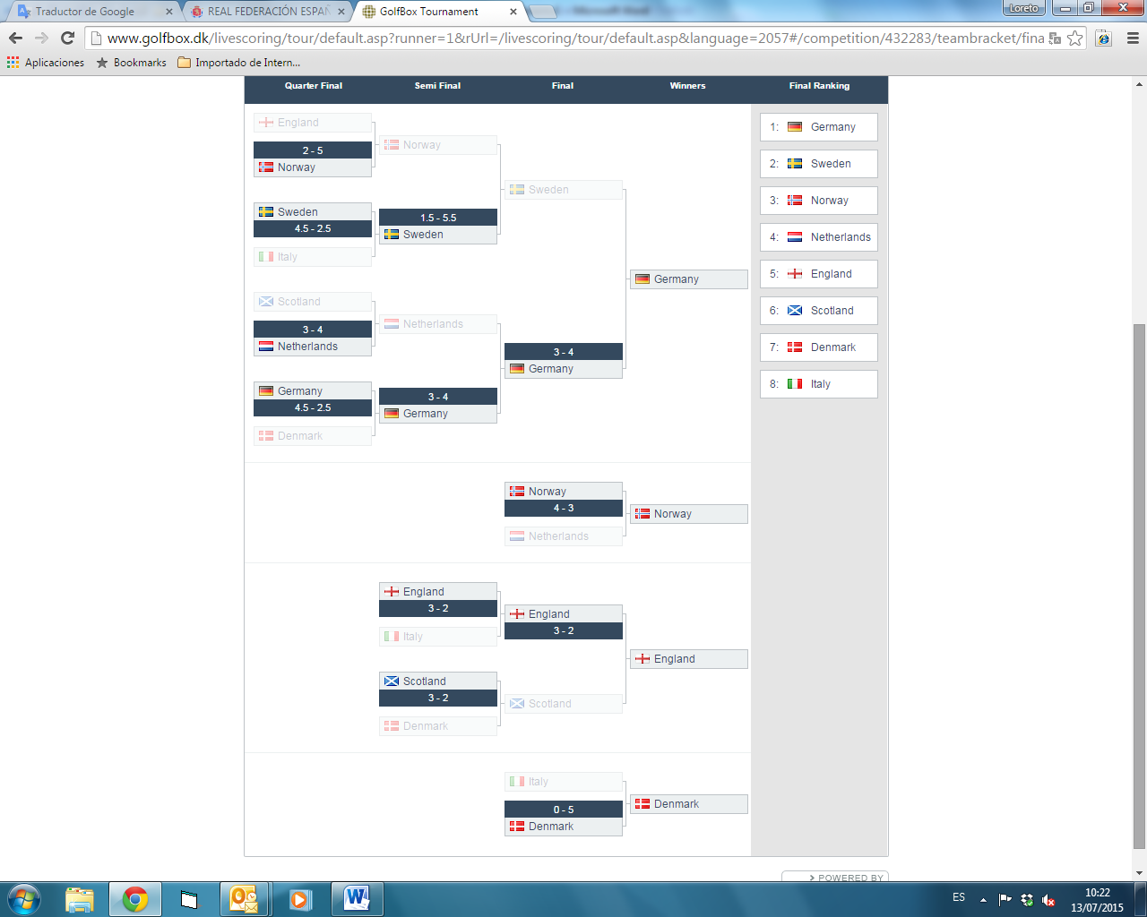
European Boys' Team Championship
Pickala Golf, Finland
07/07/2015 - 11/07/2015

FLIGHT B

- Jean-Louis Dupont Trophy
Pickala Golf, Finland
07/07/2015 - 11/07/2015

FLIGHT B

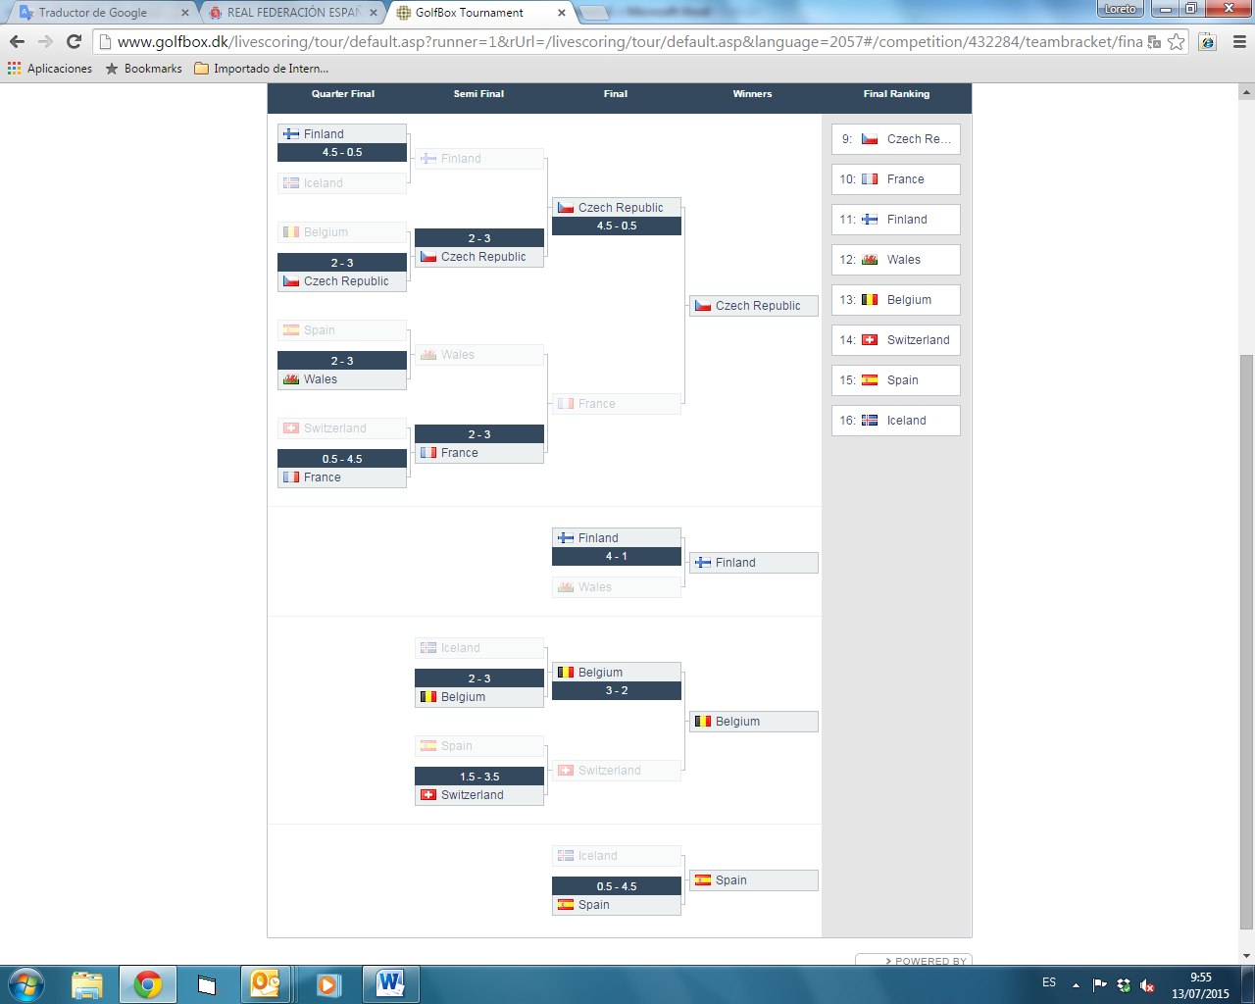
European Boys' Team Championship
Pickala Golf, Finland
07/07/2015 - 11/07/2015

FASE CLASIFICATORIA:

