


REAL FEDERACIÓN ESPAÑOLA DE GOLF

C/ Arroyo del Monte, 5 - 28035 MADRID - T: (34) 91 376 91 30 - F: (34) 91 556 32 90 - rfegolf@rfegolf.es - www.rfegolf.es

SPANISH INTERNATIONAL SENIOR AMATEUR CHAMPIONSHIP
La Manga Club (South Course). 7-9 February 2014

GOLF COURSE LA MANGA CLUB (South Course)
Ctra. Atamaria s/n
30389 Los Belones
Cartagena - Murcia (Spain)
Tel.: 968 33 12 34 - Ext: 8081 / 968 17 50 00 – Ext: 1360
e-mail: golf@lamangaclub.com
Web: http://lamangaclub.es

HOW TO
GET THERE: GPS coordinates: 37.6043,-0.8025
Nearest Airports: Murcia Airport (San Javier) – 25 km.
Alicante Airport (El Altet) – 120 km.

Airport transfers:
San Javier - La Manga Club - 50 Euros approx. (3 people)
Alicante - La Manga Club - 130 Euros approx. (3 people)

DATES: 7th to 9th February 2014
Official Practice Day: 6th February 2014
(To reserve practice time, please contact the Golf Club directly)

CONDITIONS: The Championship Conditions is enclosed to this information on page 4.
(Exact handicap limit: 18,4)

ENTRIES: Entries must be submitted ONLINE http://www.rfegolf.es by 23:59 hours, January 22nd, 2014. Entries failing this condition will not be accepted.

For Spanish Players, the official exact handicap to make the list of accepted players will be listed in the database of the RFEG at 10:00 a.m. the day after the closing date. For Foreign Players, the official exact handicap used for all purposes will be the certified handicap at date of entry for their National Golf Federation, Union or Association.

INSCRIPCIÓN ONLINE /ENTRIES ONLINE

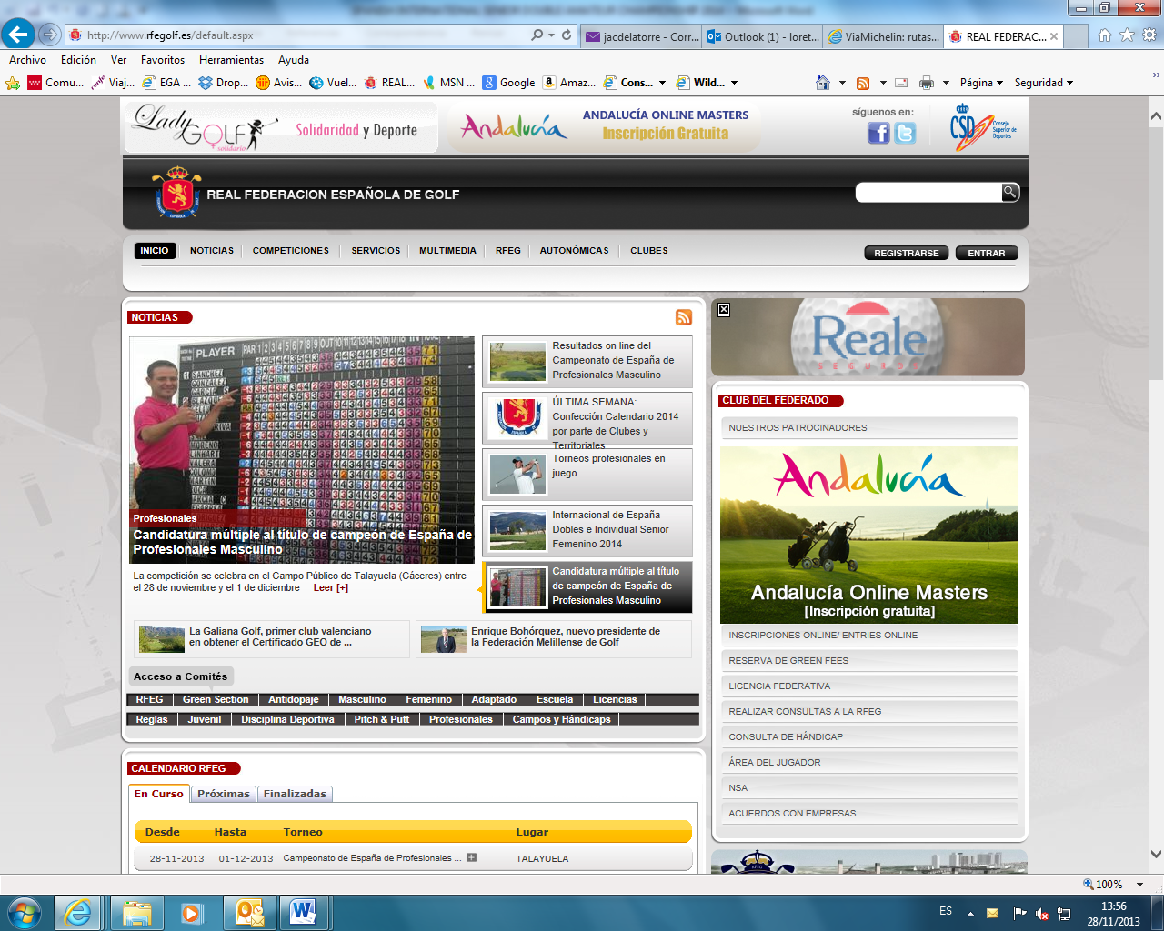

The list of accepted players and the waiting list (if any) will be published at the web site of the Royal Spanish Golf Federation (www.rfegolf.es) from the day after the closing date.

You can also require your federation to submit your entry form on your behalf. Players are responsible to check if her entry form is accepted. Any claims must be submitted within the next 24 hours after the list of participants is published.

ENTRY FEES: Entry fees should be paid upon arrival at the Club House of La Manga Club.

- Senior Players.....................................75, 00 € per player

- Golf Carts…………………………….. 35, 00 €
- Electric Trolleys…………………….. 15, 00 €
- Trolleys…………………………….……. 5, 00 €

NOTE: Golf Carts and electric trolleys must be reserved with La Manga Golf Club directly, before the championship.

REGISTER
OF PLAYERS: The register of players and the pay of the entry fee will be made in the golf club jointly, within the time and place established by the Championship Committee (on the official practice day preferably). Players who cannot go the club on the official practice day and, as such, cannot register and pay the fee by the deadline, should contact the secretary of the club or the tournament direction to confirm their participation in the championship conclusively. Failure to do so, the Championship Committee may replace the player for the appropriate waiting list (if any).

ACCOMMODATION
OFFER:
- PRINCIPE FELIPE HOTEL *****
- APARTMENTS LOMAS VILLAGE & SPA

All reservations you choose must be made through HOLE GOLF – EVENTOS 90 S.L., before JANUARY, 23rd 2014 by filling in the accommodation booking form that we herewith enclose. You must send it by e-mail to:

HOLE GOLF – EVENTOS 90 S.L.
(Att.: Mr. Iñigo Alfaro )

APPLICATIONS BY E-MAIL: alfaro@holegolf.com
Tel.: +34 948 24 10 51

Madrid, December 5th, 2013


THE GENERAL SECRETARY
LUIS ALVAREZ DE BOHORQUES

SPANISH INTERNATIONAL SENIOR AMATEUR CHAMPIONSHIP

CONDITIONS

ELIGIBILITY:
All amateur men who have reached their 55 birthday before December 31st 2014 in possession of their National Federation or Union Membership Card are eligible to play. All past winners of this championship may participate.
Entries are limited to 120 competitors with the following criteria:

A) The 100 lowest exact handicap players. In case of a tie por the 100th place, participation will be by the player earlier registered. All unsuccessful entrants will be informed immediately thereafter, but will be given the opportunity to compete if scratching subsequently occurs. Entrance fees will be refunded to entrants balloted out who do not compete.

B) The 20 Spanish Nationality lowest exact handicap players not included in group A. In case of applications exceeding this number, entries for the highest handicap competitors will be established by order of registration. All unsuccessful entrants will be informed immediately thereafter, but will be given the opportunity to compete if scratching subsequently occurs. Entrance fees will be refunded to entrants balloted out who do not compete.

In case of applications exceeding this number, entries for the highest exact handicap competitors will be decided by order of registration. If a competitor is not able to participate, for any reason, he must communicate his decision to the Championship Committee at the Club or to the Men Amateur Technical Committee of the Royal Spanish Golf Federation before 12:00 a.m. of two days before the starting of the championship. Competitors failing to do this will not be able to participate in the following year’s edition. Unsuccessful entrants will be informed immediately after the closing date and will be placed on a reserve list, by exact handicap order, and given the opportunity to compete if there are subsequent withdrawals. The possible reported absences in the specified period will be covered one by one. The used criteria for establishing priorities among players with the same exact handicap on the reserve list will be the earliest date of registration.

- Exact Handicap Limit: 18, 4.
- Golf Carts will be allowed and should be shared in order to avoid more than two buggies in each match.

FORMAT:
Over three rounds of 18 holes Stroke Play each day. Participants will play from yellow marks. After the 2nd round, a cut will be established with the first 60 qualified players and ties will qualify for the 3rd round. The Championship Committee reserves the right to amend the Rules or Conditions, should this be deemed necessary. The scratch winner will be considered the winner.

In the event of a tie for the first place, the winner shall be decided by a sudden death play-off. The championship committee will lay down the order of the holes to play. If it is not fixed, the natural order will prevail. All the ties for the runner up position will be considered ex-aequo. The runner – up trophy will be awarded to the highest playing handicap player.
For the Scratch categories, the three rounds will count. If any representative of the 2nd or 3rd scratch category does not qualify for the 3rd round, the final classification of these categories will be established after the 2nd round. The handicap classification will be established after the 2nd round.

CATEGORIES:
The Categories will be the following:

1st Category: Competitors with any exact handicap.
2nd Category: Competitors with an exact handicap index of 4, 5 or higher.
3rd Category: Competitors with an exact handicap index of 18, 5 or higher.

To compete in a category must have a minimum of six players participating.

ENTRIES:
Entries must be submitted ONLINE (www.rfegolf.es). The entry fee of 75, 00 € will be paid upon arrival at the Club House, before the tournament.

STARTING TIMES:
The starting times will be established by the Championship Committee.

PRIZES:
Trophies will be provided by Royal Spanish Golf Federation:

- Champion.
- Runner-up. All the ties for the runner-up position will be considered ex - aequo. The trophy for the runner-up will be awarded to the highest playing handicap player.

Categories:
- 2nd category Scratch Winner (*)
- 3rd category Scratch Winner (*)
- 2nd category Scratch runner-up (*)
- 3rd category Scratch runner-up (*)
- Handicap winner (**)
- Handicap Runner-up (**)

(*), (**) Ties will be decided according to the Royal Spanish Golf Federation Green Book:
(*) In case of ties for scratch competitions, the winner will be the highest playing handicap player.
(**) In case of ties for handicap competition, the winner will be the lowest playing handicap player.

Scratch Prizes will be accumulative. Handicap Prizes will not be accumulative with Scratch Prizes.
Scratch prizes (1st or 2º of any category) will prevail over Handicap prizes.


Eventos 90 S.L.
Pamplona
Tel. (+34) 948 24 10 51
APPLICATIONS BY E-MAIL: alfaro@holegolf.com

SPANISH INTERNATIONAL SENIOR AMATEUR CHAMPIONSHIP
La Manga Club (South Course). 7-9 February 2014

ACCOMMODATION REQUEST

DETAILS FOR THE CONFIRMATION: YOU MUST SEND BY E-MAIL TO: alfaro@holegolf.com

Surname: |  | Name
Passport Nº |  | Mobile Nº:
Country | Telephone:
E-mail (IMPORTANT):
Player (1)
Player (2)

BEFORE 23rd JANUARY

Establishment | Cat. | Block | Accommodations | Accommodations | Accommodations | Breakfast
PRINCIPE FELIPE HOTEL  Located on the golf club  www.lamangaclub.com | 5  * * * * * | 75 | Single Room  DUI  1 person  119 €/n.  VAT included | Twin Room  2 people  130 €/n.  VAT included | Twin Room + additional bed  3 people  Consult | INCLUDED  Buffet
LOMAS VILLAGE & SPA  Located in the golf club resort  www.lamangaclub.com | 4 | Apartments  20  1 bedroom  18  2 bedrooms  8  3 bedrooms | Apartment  1 bedroom  Duplex  1-2 people  110 €/n.  VAT included | Apartment  2 bedrooms  2-4 people  144 €/n.  VAT included | Apartment  3 bedrooms  4-6 people  175 €/n.  VAT included | Breakfast not included  Cleaning every 2 days included

Rates per room/apartment and night. VAT INCLUDED. DUI: Twin room for individual use.

POSSIBILITY OF PLAYING COMPANIONS IN OTHER COURSE

ACCOMMODATION REQUERIMENTS

Arrival Date: Departure Date:

Principe Felipe Hotel: Single Room Twin Room Twin Room+additional bed:

Apartment: 1 bedroom-Duplex (Nº units)

Apartment: 2 bedrooms (Nº units) 3 bedrooms (Nº units)

DEAD LINE: 23rd JANUARY 2014

