


REAL FEDERACIÓN ESPAÑOLA DE GOLF

C/ Arroyo del Monte, 5 - 28035 MADRID - T: (34) 91 376 91 30 - F: (34) 91 556 32 90 - rfegolf@rfegolf.es - www.rfegolf.es

BALEARES CUP

Pula Golf - 5th - 8th de February 2015

– Counting Event for the R&A World Amateur Golf Ranking –

COURSE: PULA GOLF
Ctra. Son Servera a Capdepera, km. 3
Son Servera – Mallorca
Tel.: 971 81 70 34 – Fax: 971 81 70 35
E-mail: reservas@pulagolf.com
Web: http://www.pulagolf.com/es/golf/

HOW TO
GET THERE: Nearest Airport: Palma de Mallorca Airport: 70 km
https://maps.google.com/maps?ll=39.647335,3.381503&z=15&t=m&hl=es-ES&gl=US&mapclient=embed&cid=10533852154026782780&output=classic&dg=brw
Pula Golf: 3 km. from Son Servera

DATES: 5th - 8th February 2015
Official Practice Day: 4th February 2015
(To reserve practice times, please contact the Golf Club directly)

ENTRIES: Entries must be submitted ONLINE http://www.rfegolf.es by 23:59 hours, January 21st, 2015. Entries failing this condition will not be accepted.
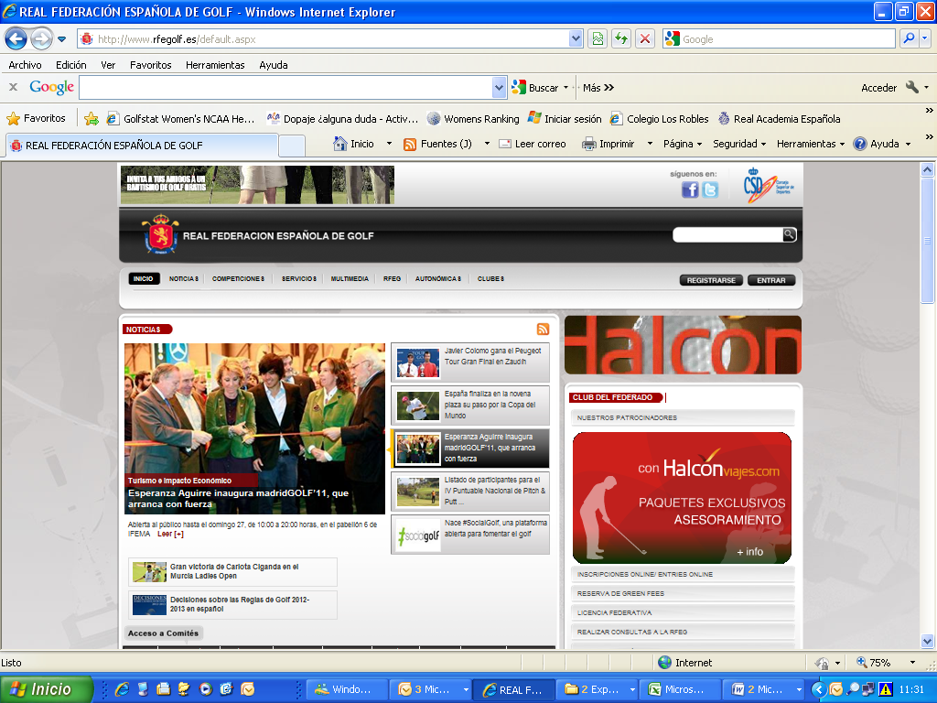

Players should select the competition, click on “entries online”

After that, player must click on the box: “I am a foreign player” and fills player’s details required for the competition.

For Spanish Players, the official exact handicap to make the list of accepted players will be listed in the database of the RFEG at 10:00 a.m. the day after the closing date. For Foreign Players, the official exact handicap used for all purposes will be the certified handicap at date of entry by their National Golf Federation, Union or Association.

The list of accepted players and the waiting list (if any) will be published at the web site of the Royal Spanish Golf Federation (www.rfegolf.es) from the day after the closing date.

You can also require your federation to submit your entry form on your behalf. Players are responsible to check if her entry form is accepted. Any claims must be submitted within the next 24 hours after the list of participants is published.

ENTRY FEES: Entry fees fees should be paid upon arrival at the Clubhouse of Pula G.C.:

- Amateur Players…………………………………. 75, 00 €
- Under 21 Players……………………….………… 35, 00 €

TROLLEYS: Electric Trolleys must be booked directly with Pula Golf, before 28th January (Phone: 971 81 70 34).

- Manual trolley 4€/day
- Electric trolley .15€/day

REGISTER
OF PLAYERS: The register of players and the pay of the entry fee will be made in the golf club jointly, within the time and place established by the Championship Committee (on the official practice day preferably). Players who cannot go the club on the official practice day and, as such, cannot register and pay the fee by the deadline, should contact the secretary of the club or the tournament direction to confirm their participation in the championship conclusively. Failure to do so, the Championship Committee may replace the player for the appropriate waiting list (if any).

CONDITIONS: The Championship Conditions is enclosed to this information.
(Exact handicap limit: 11.4)

ACCOMMODATION
OFFER:
- HOTEL PETIT HOTEL SES CASES DE PULA ****
- SENTIDO PULA SUITES GOLF & SPA *****

All reservations you choose must be made through HOLE GOLF – EVENTOS 90 S.L., before JANUARY 21st, 2015 by filling in the accommodation booking form that we herewith enclose. You must send it by e-mail to:

HOLE GOLF – EVENTOS 90 S.L.
(Att.: Mr. Iñigo Alfaro )

APPLICATIONS BY E-MAIL: alfaro@holegolf.com
Tel.: +34 948 24 10 51

Madrid, November 20th, 2014


THE GENERAL SECRETARY
LUIS ALVAREZ DE BOHORQUES

BALEARES CUP
Counting Event - R&A World Amateur Golf Ranking

CONDITIONS

Eligibility:

Any amateur player, with an exact handicap of 11.4 or better, in possession of their National Federation or Union Membership Card is eligible to enter. All entries will be subject to the approval of the Amateur Committee from the Royal Spanish Golf Federation which reserves the right to accept or refuse. There will be no handicap limit for past Champions.

Entries are limited to 87 competitors. If the number of entries exceeds these, the high-handicap players will be eliminated from the championship by draw. In addition, the Baleares Golf Federation will have 3 invitations. If these 3 players had an exact handicap higher than the 87 admitted, will increase the total number admitted to not take place any of the other registered.

For Spanish Players, the official exact handicap to make the list of accepted players will be listed in the database of the RFEG at 10:00 am the day after the closing date. For foreign players, the official exact handicap used for all purposes will be the handicap certified at date of entry by their National Golf Federation, Union or Association.

If, for any reason, a competitor is unable to participate, he must communicate this to either the Championship Committee at the Club or to the Amateur Technical Committee or the Royal Spanish Golf Federation before 12:00 am of two days before the starting of the championship. Any player who fails to follow this procedure risks having his entry refuses for the following year’s edition.

Unsuccessful entrants will be informed immediately after the closing date and will be placed on a reserve list, by exact handicap order, and given the opportunity to compete if there are subsequent withdrawals. The possible absences reported in the specified period will be covered one by one. The criteria used for establishing priorities among players with the same exact handicap on the reserve list will be the earliest date of entering.

The register of players and the pay of the entry fee will be made in the golf club jointly, within the time and place established by the Championship Committee (on the official practice day preferably). Players who cannot go the club on the official practice day and, as such, cannot register and pay the fee by the deadline, should contact the secretary of the club or the tournament direction to confirm their participation in the championship conclusively. Failure to do so, the Championship Committee may replace the player for the appropriate waiting list (if any).

Format:

Over four rounds of 18 holes stroke play scratch each day (72 holes from white marks). After the 3rd round, a cut will be established. The first 50 qualified players and ties will qualify for the 4th round.

In the event of a tie for the first place, the winner shall be decided by a sudden death play-off. The championship committee will lay down the order of the holes to play. If it is not fixed, the natural order will prevail. For the rest of categories, ties will be decided according to the Royal Spanish Golf Federation Green Book for scratch competitions (trophy will be awarded to the highest playing handicap player).

For all the scratch classifications the four rounds will count. If for any reason, any representative of the scratch categories does not qualify for the 4th round, the prize for that given category will not be presented.

Note: The Championship Committee reserves the right to amend the championship conditions, should this be deemed necessary.

Entries:

Entries must be submitted ONLINE (www.rfegolf.es). The closing date and the entry fee will be determined by the Royal Spanish Golf Federation each year. The entry fee should be paid upon arrival at the Golf Club, before the championship.

Starting Times

The Championship Committee will establish the order and the starting times for each round.

PRIZES

The Baleares Golf Federation will offer trophies to the scratch champion, scratch runner-up and to the scratch third placed. The first scratch under-18 player placed and the first scratch under-16 player placed will receive trophies too.

To compete in a category, must have a minimum of six players participating.

THE PRIZES WILL BE NOT ACCUMULATIVE.

1st, 2nd & 3rd scratch prizes will prevail over the rest.

No more prizes may be submitted without the agreement of the Amateur Committee of the Royal Spanish Golf Federation.


Eventos 90 S.L.
Pamplona
Tel. (+34) 948 24 10 51
REQUEST BY e-mail: alfaro@holegolf.com

BALEARES CUP
Pula Golf - 5th - 8th February 2015

ACCOMMODATION REQUEST FORM

DETAILS FOR THE CONFIRMATION: YOU MUST SEND BY E-MAIL TO: alfaro@holegolf.com

Surname: |  | Name:
Passport Nº: |  | Mobile Nº:
Country: | Telephone:
E-mail (IMPORTANT):
Player (1)
Player (2)

ESTABLISHMENT | Cat. | BLOCK | SINGLE ROOM  (DUI) | DOUBLE ROOM | DOUBLE ROOM + ADITIONAL BED | Breakfast | Dinner
PETIT HOTEL SES CASES DE PULA  Wifi Free  http://www.pulagolf.com/es/ | 4  **** | 6 | 85 €/night  VAT Included | 110 €/n.  VAT Included | 145 €/n.  VAT Included | INCLUDED  Buffet | Consult
SENTIDO PULA SUITES  En el tee del Hoyo 1  Restaurante, cafetería, etc.  Wifi gratuito.  http://www.stilhotels.com/hoteles/hotel-sentido-pula-suites-golf-spa/ | 4  ****S | 45 | 73 €/noche  VAT Included | 90 €/n.  VAT Included | 130 €/n.  VAT Included | INCLUDED  Buffet | Consult
APARTAMENTOS  VILLA PULA GOLF  A lo largo dell Hoyo 1  Apartamentos impecables y totalmente equipados. Cocina completa con todos los útiles para cocinar. Incluida limpieza diaria y desayuno por persona. Wifi gratuito.  http://www.stilhotels.com/hoteles/hotel-sentido-pula-suites-golf-spa/ | 3  llaves | 10 | Apart.  1 Bedroom  2 person  100 €/n  VAT Included | Apart.  2 Bedroom  2 bathroom  4 Persons  160 €/n  VAT Included | Apart. 3 3 Bethrooms  3 bathrooms  -6 persons  240 €/n.  VAT Included | INCLUIDO  buffet | Consult

Rates per room. VAT INCLUDED. DUI: Twin room for individual use.
ACCOMMODATION REQUERIMENTS

ESTABLISHMENT:

Arrival Date Departure Date Departure according to the cut

Single Room DUI Twin Room Twin Room+additional bed:

Apart. 1 Dormitorio: Apart. 2 Dormitorios: Apart. 3 Dormitorios:

DEAD LINE: 21st JANUARY 2015
Accommodation will be confirmed after the list of participants is publishes

