


REAL FEDERACIÓN ESPAÑOLA DE GOLF

C/ Arroyo del Monte, 5 - 28035 MADRID - T: (34) 91 376 91 30 - F: (34) 91 556 32 90 - rfegolf@rfegolf.es - www.rfegolf.es

SPANISH INTERNATIONAL SENIOR DOUBLE AMATEUR CHAMPIONSHIP
Oliva Nova Golf – 11-12 February 2015

GOLF COURSE: OLIVA NOVA GOLF

Urbanización Oliva Nova

46780 Oliva, Valencia
Teléfono: 962 857 666
E-mail: proshop@olivanova.com
Web: http://www.golf.olivanova.com

HOW TO
GET THERE: GPS Cordinates: N 38.53.59 | W 00.03.37
Nearest Airports: Valencia Airport - 85 Km
Alicante Airport - 95 Km.

From Alicante - AP7 motorway towards Valencia. Exit 62 Ondara / Denia. The towards Oliva / Valencia 12 km on the N-332 to the Km 210, turnoff Urbanización.
From Valencia - Motorway AP7 towards Alicante. Exit 61 Oliva/Pego. Traverse Oliva through N-332 and continue 5 km until reaching the Km 210 turnoff Urbanización (Residential area).

DATES: 11th and 12th February 2015
Officials Practice Days: 9th & 10th February 2015
(To reserve practice time, please contact the Golf Club directly)

CONDITIONS: The Championship Conditions is enclosed to this information on page 4.

ENTRIES: Entries must be submitted ONLINE http://www.rfegolf.es by 23:59 hours, January 28th, 2015. Entries failing this condition will not be accepted.

For Spanish Players, the official exact handicap to make the list of accepted teams will be listed in the database of the RFEG at 10:00 a.m. the day after the closing date. For Foreign Players, the official exact handicap used for all purposes will be the certified handicap at date of entry for their National Golf Federation, Union or Association.

The list of accepted teams and the waiting list (if any) will be published at the web site of the Royal Spanish Golf Federation (www.rfegolf.es) from the day after the closing date.

INSCRIPCIÓN ONLINE /ENTRIES ONLINE

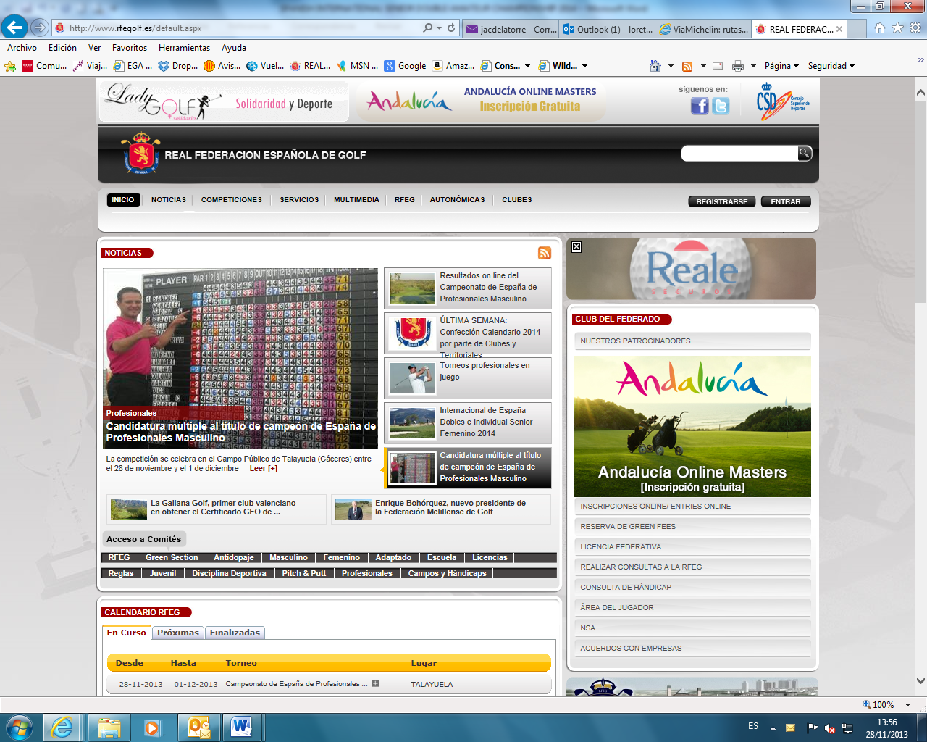

Players should select the competition, click on “entries online”

After that, player must click on the box: “I am a foreign player” and fills player’s details required for the competition.

You can also require your federation to submit your entry form on your behalf. Players are responsible to check if her entry form is accepted. Any claims must be submitted within the next 24 hours after the list of participants is published.

ENTRY FEES: Entry fees should be paid upon arrival at the Club House of Oliva Nova Golf.

- Senior Players.................................... 75, 00 € per player
(150, 00 € per team)

- Golf Carts………………………… 36, 00 €
- Electric Trolleys… 14, 00 €
- Trolleys……………………………. 5, 00 €

NOTE: Golf Carts and electric trolleys must be reserved before 3rd January with Oliva Nova Golf directly.

REGISTER
OF PLAYERS: The register of players and the pay of the entry fee will be made in the golf club jointly, within the time and place established by the Championship Committee (on the official practice day preferably). Players who cannot go the club on the official practice day and, as such, cannot register and pay the fee by the deadline, should contact the secretary of the club or the tournament direction to confirm their participation in the championship conclusively. Failure to do so, the Championship Committee may replace the player for the appropriate waiting list (if any).

ACCOMMODATION
OFFER:
- HOTEL OLIVA NOVA
- APARTMENTS

All reservations you choose must be made through HOLE GOLF – EVENTOS 90 S.L., before JANUARY 18th, 2015 by filling in the accommodation booking form that we herewith enclose. You must send it by e-mail to:

HOLE GOLF – EVENTOS 90 S.L.
(Att.: Mr. Iñigo Alfaro )

APPLICATIONS BY E-MAIL: alfaro@holegolf.com
Tel.:+34 948 24 10 51

Madrid, November 19th, 2014


THE GENERAL SECRETARY
LUIS ALVAREZ DE BOHORQUES

SPANISH INTERNATIONAL SENIOR DOUBLE AMATEUR CHAMPIONSHIP

CONDITIONS

ELIGIBILITY:
All amateur men who have reached their 55 birthday before December 31st 2015 in possession of their National Federation or Union Membership Card are eligible to play. All past winners of this championship may participate.
Entries are limited to 60 teams of competitors that will be the 60 teams with the lowest handicap addition. In case of a tie for the 60th place participation, will be by the pair of players earlier registered.
If a team of competitors is not able to participate, for any reason, they must communicate their decision to the Championship Committee at the Club or to the Men Amateur Technical Committee of the Royal Spanish Golf Federation before 12:00 a.m. of two days before the starting of the championship. Competitors failing to do this will not be able to participate in the following year’s edition. Unsuccessful entrants will be informed immediately after the closing date and will be placed on a reserve list, by handicap addition order, and given the opportunity to compete if there are subsequent withdrawals. The possible reported absences in the specified period will be covered one by one. The used criteria for establishing priorities among teams with the same handicap addition on the reserve list will be the earliest date of registration.

- Golf Carts will be allowed and should be shared in order to avoid more than two buggies in each match.

FORMAT:
Stroke Play Scratch over two rounds of 18 holes each day. First day 18 holes-Best Ball and second 18 holes Greensome. Participants will play from yellow marks.

The Championship Committee reserves the right to amend the Rules or Conditions, should this be deemed necessary. The scratch winner will be considered the winner team.

In the event of a tie for the first place, the winner shall be decided by a sudden death play-off. The championship committee will lay down the order of the holes to play. If it is not fixed, the natural order will prevail. All the ties for the runner up position will be considered ex-aequo. Any draw for every spot will be resolved, according with the Green Book of the Royal Spanish Golf Federation (at scratch classification will be awarded to the highest playing handicap team and at handicap classification will be awarded to the lowest playing handicap team).

ENTRIES:
Entries must be submitted ONLINE (www.rfegolf.es). The entry fee of 75, 00 € per player (150, 00 € per team) will be paid upon arrival at the Golf Club, before the tournament.

TEE-OFF:
First competition day: the order will be established by the Championship Committee. The order on the second day will be by classification.

PRIZES:
The Scratch Champion team will award a trophy that will be provided by Royal Spanish Golf Federation.
The Scratch runner-up team will award a trophy. All the ties for the runner-up position will be considered ex-aequo. The trophy for the runner-up will be awarded to the highest playing handicap team of competitors.

The Handicap Champion and handicap runner-up teams will award a trophy. In case of tie for this handicap classification, the trophy will be awarded to the lowest playing handicap team of competitors.


Eventos 90 S.L.
Pamplona
Tel. (+34) 948 24 10 51
REQUEST BY e-mail: alfaro@holegolf.com

SPANISH INTERNATIONAL SENIOR AMATEUR CHAMPIONSHIP
Oliva Nova Golf
11-12 February (double) / 13-15 February 2015 (single)

ACCOMMODATION REQUEST

DETAILS FOR THE CONFIRMATION: YOU MUST SEND BY E-MAIL TO: alfaro@holegolf.com
Surname: |  | Name
Passport Nº |  | Mobile Nº:
Country | Telephone:
E-mail (IMPORTANT):
Player (1)
Player (2)

Establishment | Cat. | Block | Accommodations | Accommodations | Accommodations | Breakfast
HOTEL OLIVA NOVA  600 mts. From House Club  Gimnasy & wifi Free  www.olivanova.com | 4  * * * * | 70 | Habitación  DUI – 1 person  76,5 €/night  VAT included | Double Room  2 person  99 €/n.  VAT included | Rooms  3 person  Consult | INCLUIDED  Buffet
APARTAMENTOS  200-900 mts. From House Club.  Cleaning: 15 €/hour  www.olivanova.com | 3  Keys | 3 of 1  Bedrooms  8 - 2 Bedroom  3 - 3 bedroom | Estancia > 3 noche  Apartment  1 bedroom  2 person  57,2 €/noche  SUPERIOR  74,8 €/noche  Promotion:  7 x 5 nights  VAT included | Estancia > 3 noche  Apartment  2 bedroom  4 person  66 €/n.  SUPERIOR  92,4 €/n.  Promotions  7 x 5 nights  VAT included | Estancia > 3 noche  Apartment  3 bedroom. – 2 bathroom  6 person  70,4 €/n.  SUPERIOR  105,6 €/n.  Promotion:  7 x 5 nights  VAT included | INCLUIDED  Buffet  Cleaning  NO INCLUIDED

Rates per room/apartment and night. VAT INCLUDED. DUI: Twin room for individual use.
ACCOMMODATION REQUERIMENTS

ESTABLISHMENT:

Arrival Date: Departure Date:

Hotel: Single Room Twin Room Twin Room+additional bed:

Apartment 1 Bedroom: Ap. 2 Bedrooms: Ap. 3 Bedrooms:

DEAD LINE: 18th JANUARY 2015
Accommodation will be confirmed after the list of participants is publishes

