PARA / TO: Mr. Tommy Horton
DE / FROM: Mr. Ernesto Fernández de Gamboa
FECHA / DATE: 14th October 2014
Nº FAX / FAX: +44 1534 857813 Nº PÁG. / 2PAGES:

2014 SHORT GAME COACHING

Dear Tommy:
Following our telephone conversation and regarding the Short Game clinic, scheduled from the 24th – 28th October at Costa Ballena Golf Resort. Herewith I enclose you a copy of this year contract in order to sign it and return it as soon as possible.
We also need the confirmation of your all your bank details in order to proceed with the transfer. Are they OK?:

- BANK (Name and address).
NATIONAL WESTMINTER, 16 LIBRARY PLACE, ST. HELIER, JERSEY JE48NI, U.K.
- Account number. 61015784
- IBAN GB89NWBK 61020361015784
- SWIFT RBOSJESH

Regarding your accommodation. The selected hotel will be the same as last year

Hotel Elba Costa Ballena Beach & Thalasso Resort
Urb. Costa Ballena, Avda. Carla de Orleans, s/ n | 11520 - Ro - Cádiz
Tlf.: + 34 956 84 92 00 | Fax.: +34 956 84 70 41

We’ve booked a double room for you and Helen.

As we did last year, you will star working with the girls the 24th & 25th and with the boys the 26th afternoon, the 27th and the 28th until lunch time. On the 26th morning we will have a short game & putting competition.

I’ll see you the 25th in the evening.

Looking forward to hearing from you.

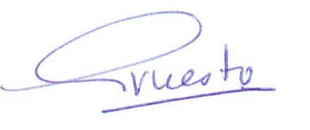
Best Regards

Ernesto Fernández de Gamboa
Director Deportivo

