TOURNAMENT AGRONOMY PREPARATION REPORT

PRIVATE & CONFIDENTIAL

Ladies European Tour
Buckinghamshire Golf Club
Denham Court Drive
Denham
Buckinghamshire
UB9 5PG
England

T: +44 1895 831028

F: +44 1895 832301

E: dgomez@rfegolf.es

W: www.ladieseuropeantour.com

In attendance: Sebastien Duteil, Head Greenkeeper
Golf de l’Ocean
Adil Benbrika Sportif
Association du Trophee Hassan II
Nabil Guessous
Association du Trophee Hassan II
David Gomez, Director Green Section
Royal Spanish Golf Federation/Ladies European Tour

Circulation: All of the above including:
Sally McPherson, Director of Tournament
Ladies European Tour
Julian Mooney, Director Agronomy
Turfgrass Consultancy/Ladies European Tour
Mark Casey, Director Operations and The Solheim Cup
Ladies European Tour

Tournament: Lalla Meryem Cup

Tournament Date: 28-31 March 2013

Visit Date: 24-29/03/2013

INTRODUCTION

The purpose of this report is to evaluate the condition of the Golf de L’Ocean during the Lalla Meryem Cup and identify any issues which needed to be addressed for the preparation of the golf course for future events.

I would like to thank the hospitality and the treatment received throughout the tournament week.

In general terms, the golf course condition during the tournament week was good.

SUMMARY OF OBSERVATIONS AND SUBSEQUENT SUGGESTIONS

Here are our findings and recommendations regarding the golf course condition during the tournament.

Greens

Greens were in very good condition, surfaces were firm under foot and with consistent grass cover.

Greens were cut twice in the morning @ 4 mm and cut single and brush in the afternoon with a triplex mower during the tournament week.

Green speed ​​was very consistent during the tournament week (it was measured with a stimpmeter resulting values ​​between 9 and 9.5 feet) and quality of ball roll was very good.

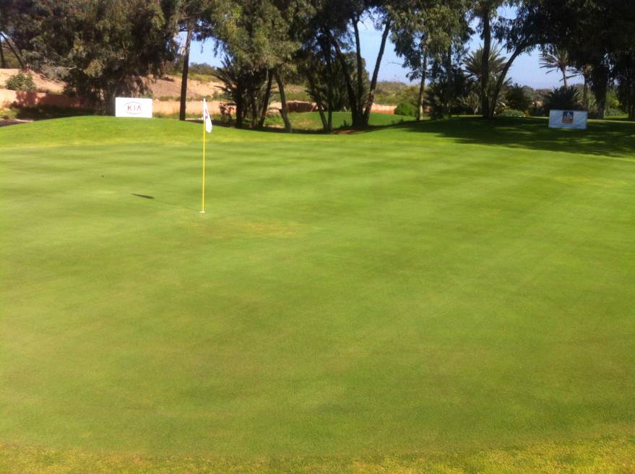
The only negative aspect was the presence of some green spots in some greens due to the stress of the maintenance schedule during the tournament.

We would recommend the next improvements for greens:

- Change topdressing sand particle size, looking for a bigger particle size silica sand and following the rule of thumb: “Coarse over fine, never fine over coarse”. The use of fine sand has reduced the number of macropores and as a result, infiltration and oxygen in the upper zone of the soil profile have been reduced too. We strongly recommend the use of coarser texture sand, which meets USGA specifications, during hollowcoring and topdressing. It will balance pore space percentage in the soil and as a result will improve infiltration and firmness.

- Follow a more aggressive verticutting and sand topdressing program.

Avant Greens (Green Collars and Approaches)

These areas were the main concern during the tournament week.

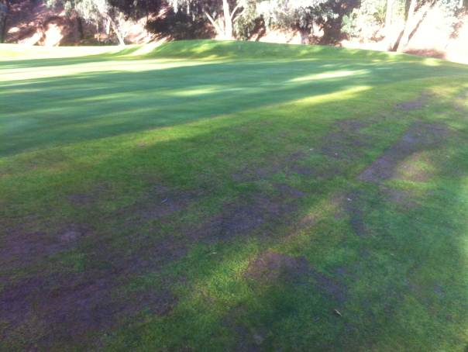 | 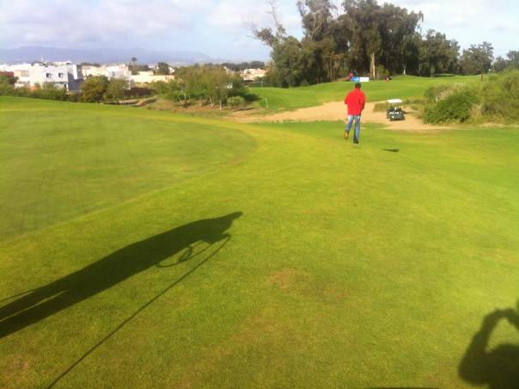
Beginning of the tournament week | End of the tournament week

Green collars and approaches, in general, showed a poor condition with inconsistent grass cover. This was mainly due to:

- Avant greens are composed for two different species: Paspalum vaginatum (warm season grass) and Lolium perenne (cool season grass). These two species have different maintenance requirements and transition is very challenging without a chemical approach.

- Overwatering. Water management can be improved.

We recommend trying to change sprinklers of the green from full circle to half circle to put less water over Paspalum. Paspalum is a C4 plant and needs less water than Agrostis (C3). Hand watering must be the best tool to correct the deficiencies of the irrigation system.

Tees

Tees were level, firm, free of diseases and showed a good consistent grass cover for the tournament, allowing a very good stand for players.

Dew was removed in the early morning and tees were cut, divot repairing and hand watering in the afternoon.

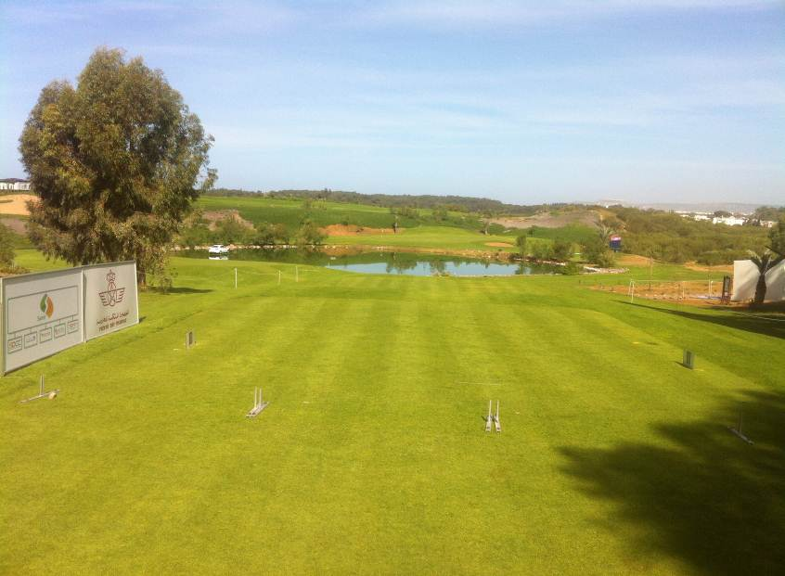

Fairways and Playable Rough

Fairways were in a very good condition, showing full grass cover, free of diseases and very firm. Without doubt was the best area of the golf course during the tournament.

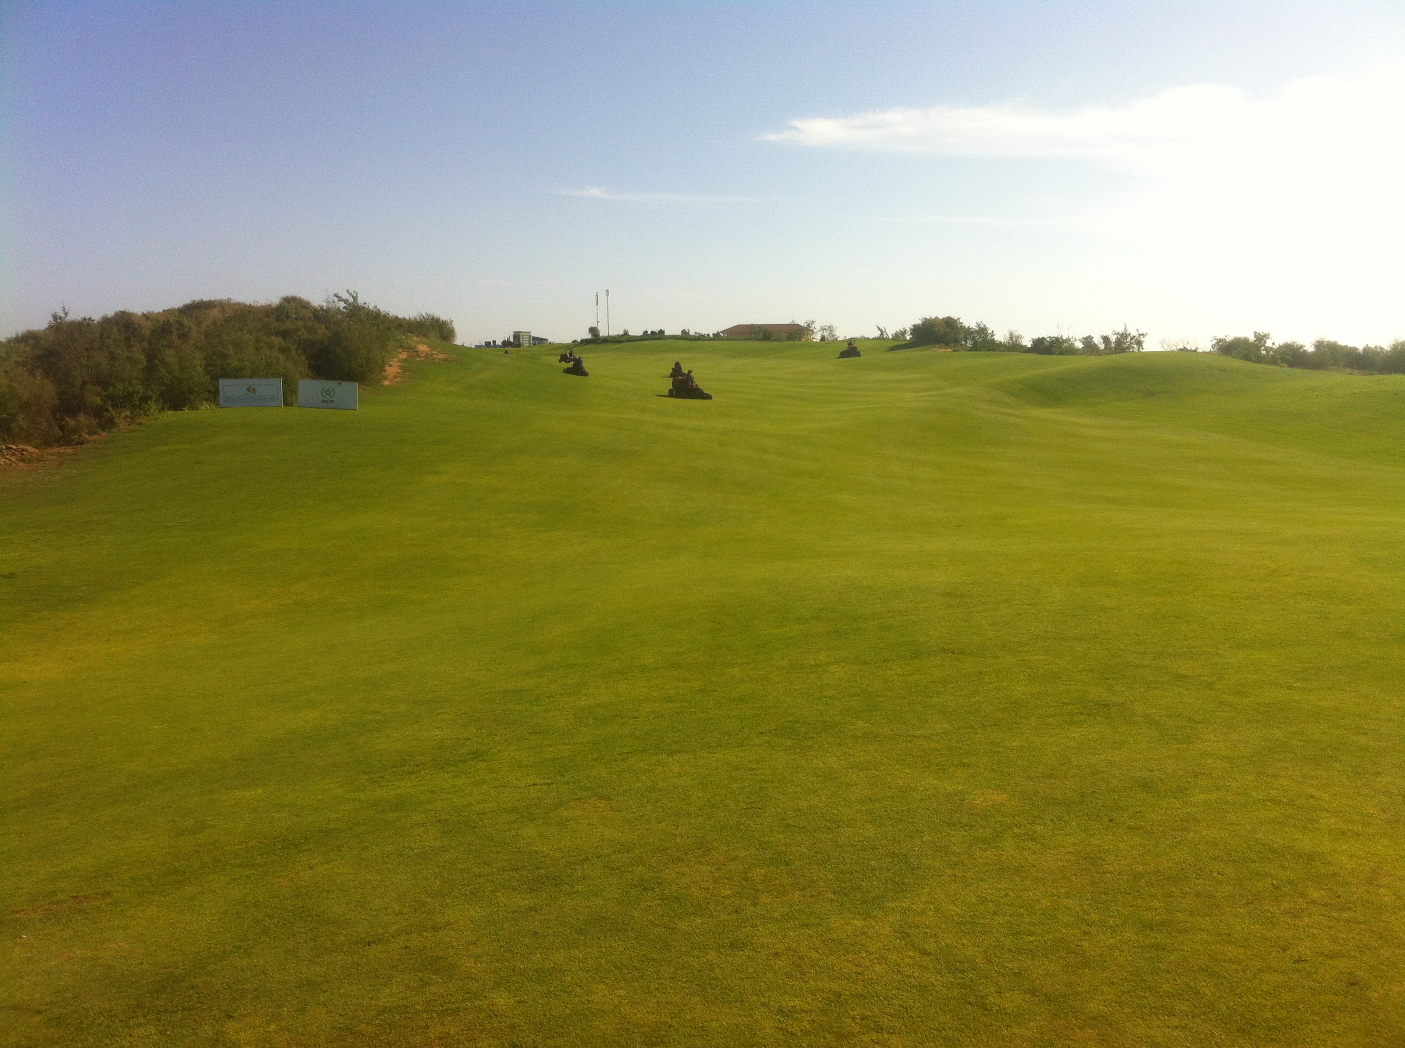

Dew was removed in the early morning and tees were cut, divot repairing and hand watering in the afternoon.

Playable rough was dense. However, there were some broadleaf weeds and the superintendent decided to remove them by lowering the height of cut. As a result, height of cut of playable rough was not enough to penalize bad shots. We strongly recommend the use of selective herbicides for future events.

Bunkers

Bunkers were very consistent and in a fair condition during the tournament. Bunkers were raked by hand, showing clearly and defined edges.

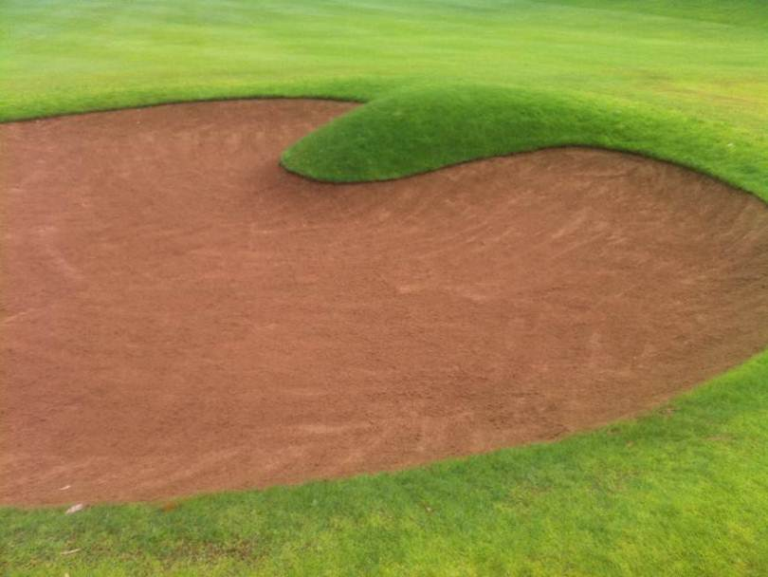
Greenkeeping Plan

 | MORNING
 | Green | Bunker | Tee and Collar | Fairway
Thursday | Pins Double cut | Yes | Dew | Dew
Friday | Pins  Double cut | Yes | Dew | Dew
Saturday | Pins Doble cut | Yes | Dew | Dew
Sunday | Pins  Double cut | Yes | Dew | Dew

 | AFTERNOON
 | Green | Bunker | Tee and Collar | Fairway
Thursday | Single cut  Brush | None | Mow  Fill the divots | Mow 18th holes Fill the divots
Friday | Single cut  Brush | None | Mow  Fill the divots | Mow 18th holes  Fill the divots
Saturday | Single cut  Brush | None | Mow  Fill the divots | Mow 18th holes Fill the divots
Sunday | None | None | None | None

Recommended Improvements

- Greens
- Change topdressing sand (coarser texture tested by a certified laboratory, USGA).
- Intensive cultural practices programme.
- Avant greens
- Change water management policy.
- Rough
- Aeration programme.
- Herbicide programme.
We really appreciate the work carried out by the Superintendent and the maintenance crew during the tournament.

Finally we would like to thank for your time and hospitality during our stay at the Lalla Meryem Cup 2013 and wish you every success for the future. If you have any questions regarding this report please contact us.

