TOURNAMENT AGRONOMY PREPARATION REPORT

PRIVATE & CONFIDENTIAL

Ladies European Tour
Buckinghamshire Golf Club
Denham Court Drive
Denham
Buckinghamshire
UB9 5PG
England

T: +44 1895 831028

F: +44 1895 832301

E: dgomez@rfegolf.es

W: www.ladieseuropeantour.com

In attendance: Rahioui Khammar
Head Greenkeeper Dar Es Salam Golf Course
Adil Benbrika Sportif
Responsible Sportif
David Gomez, Director Green Section
Royal Spanish Golf Federation/Ladies European Tour
Rebecca Hudson
Player, Board Member and Chairman of Players Council LET

Circulation: All of the above including:
Sally McPherson, Director of Tournament
Ladies European Tour

Tournament: Lalla Meryem Cup

Tournament Date: 28-31 March 2013

Visit Date: 11-13/12/2013

INTRODUCTION

After our visit to the Ocean course we checked all different areas. It is MADATORY to follow the program that we are going to develop in this document. They have not done any cultural practice to recover the grass after the summer. The following program has to be done as soon as possible. If you are not able to start the cultural practice immediately the tournament will not have success.

For different areas you HAVE TO;

- GREEN; the greens are healthy enough to work on, but they are very slow and the roll of the ball is very poor.

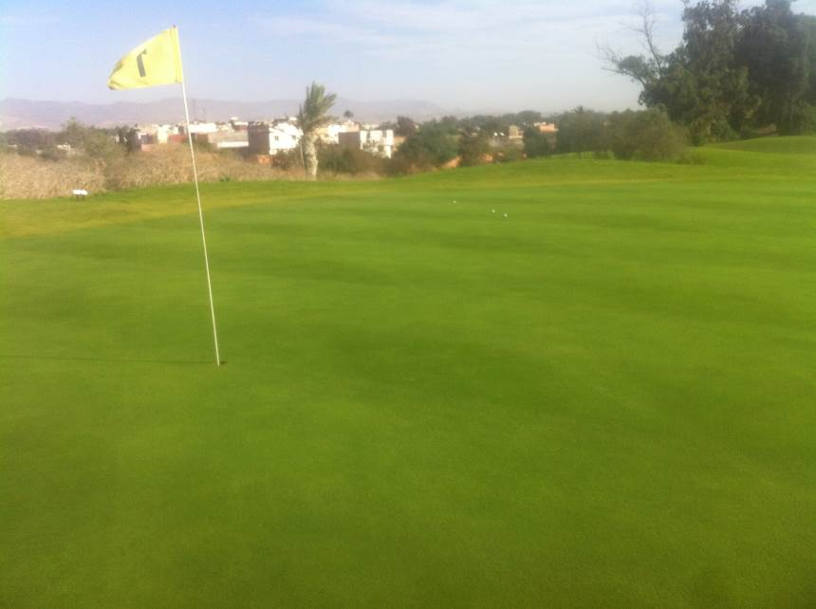

- Double Verticut, depth of -2 mm.
- Top dressing with coarse texture sand.
- Granular fertilization.
- After the recovery, grooming and brushing very light every week.
- Every ten days light top dressing.
- Spoon feeding every 10 days.

It is very important to manage the water irrigation. You must irrigate all greens differently to the collar or fairways. Half water to the fairways. It is very important to hand water beside turn on the splinker. Only apply water when is necessary. If you turn on the splinker where is not needed you will make a soft course and not healthy grass.

- TEES, COLLARS, FAIRWAYS; because of lack of cultural practices (no aerification or top dressing) we have to over-seed to get uniformity.

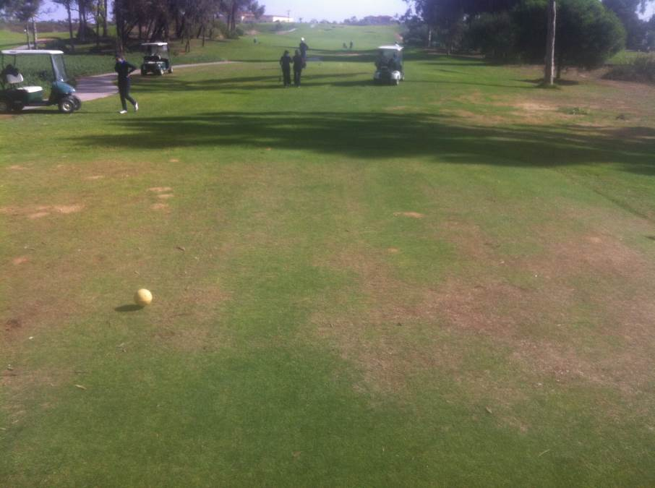

TEE

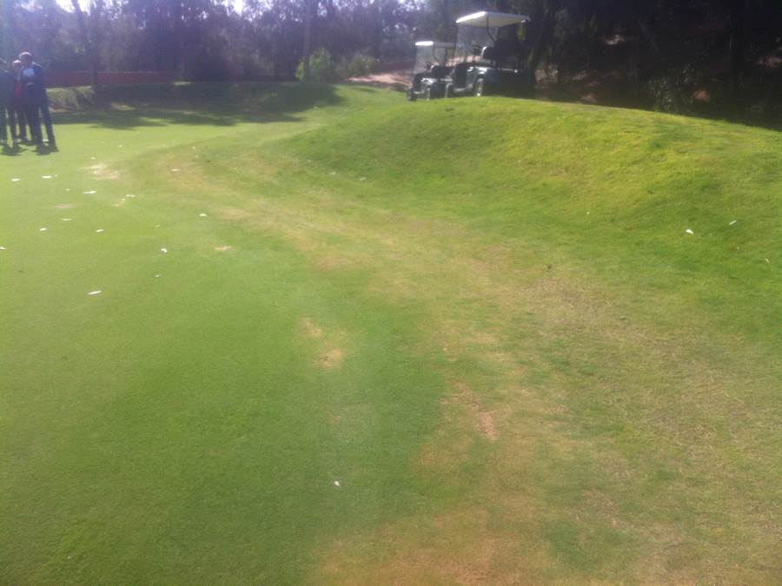

COLLAR

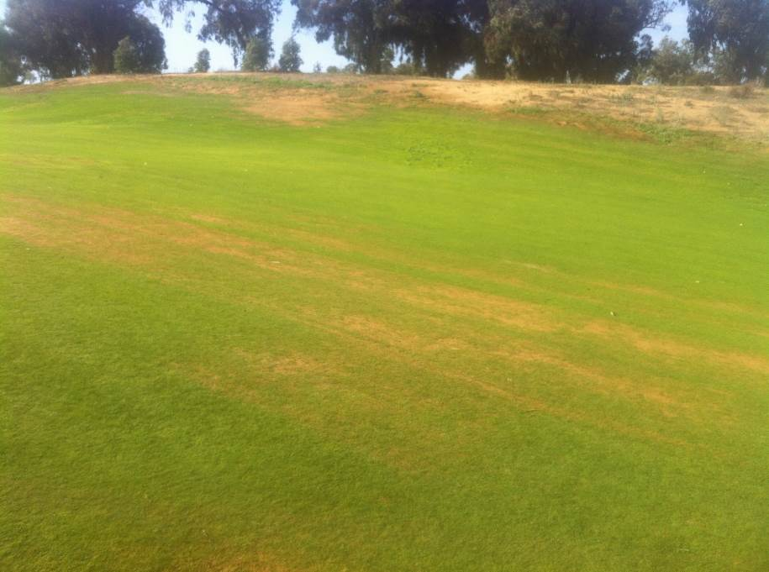

FAIRWAYS

- Hollow aerification.
- Double verticut.
- Remove all loose cuttings and course debris.
- Seeding - 50gr/m2. It is very important to get new seed. The seed that they have on the course is very old and the germination is very poor.
- Top dressing
- Granular fertilization.

- BUNKER; They are the best area of the golf course. They are uniform and the ball never does a fried egg. Please be aware of the following;

- Edge
- Do not add sand
- Remove little stones.
- Remove weeds.

F) ROUGH; The only thing we can do to improve the rough is to apply some fertilizer and also frequently mow high to get uniformity.

This program has to be started NOW if you want to have great results for the golf course. For success in the event you have to get;

- Sand for top dressing
- Machinery to do cultural practice
- New Seed
- Fertilizer
- Head Greenkeeper on the course to be sure the programs will be done properly. Mr. Khammar have to be on course supervising all the procedures.

We have been asking for the property to hire a greenkeeper. We recommended a Miguel Angel Chapaza +34 677 036 989.

We hope the information in this report is of benefit and if there are any issues which you would like to discuss further or questions which you would like to ask please do not hesitate to contact us.

