Spanish study on putting surface reliability
Greens provide acceptable surfaces after cultivation work.
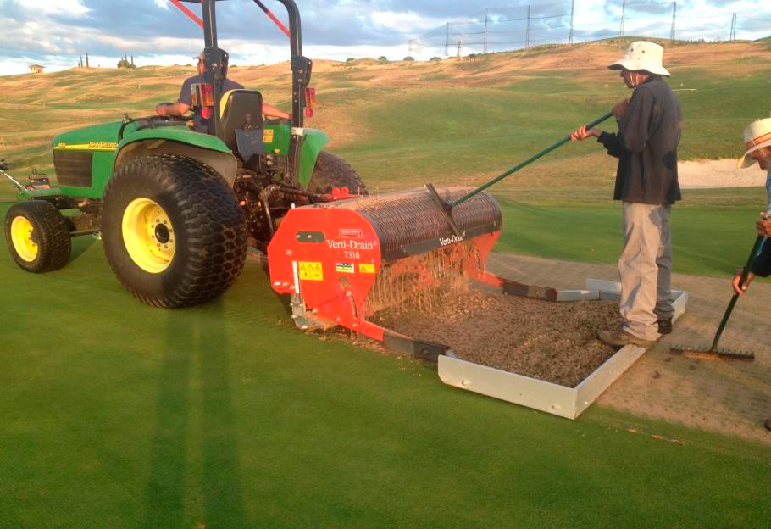

A joint research project between the Royal Spanish Golf Federation (RSGF) and the General Council for Scientific Research (CSIC), in collaboration with the Spanish Greenkeepers Association (AEdG), investigated the reliability of putting surfaces at the Centro Nacional de Golf in Madrid. The main purpose of the study was to determine the impact of cultivation treatments, namely verticutting, micro-coring and top dressing, on the quality of surfaces presented to golfers.

This project follows a study on the firmness of greens at the Centro Nacional, which was reported on these websites: www.rfegolf.es and www.aegreenkeepers.com
Concept of reliability

The green is considered the most important area for play on the golf course. The quality of the putting surface is very important to golfers, who want to be confident that their putts will have every chance of dropping into the hole if they are struck at the right speed and on the correct line. This reflects the reliability of a green and achieving this consistently is why much of the greenstaff’s time is spent on maintaining the putting surfaces. The absence of irregularities that could interfere in the ball’s trajectory when rolling towards the hole is key to presenting reliability across a putting surface. To maintain putting surfaces at optimal levels of performance, a series of cultural practices have to be implemented and these can result in a short-term reduction in the reliability of the green.

“
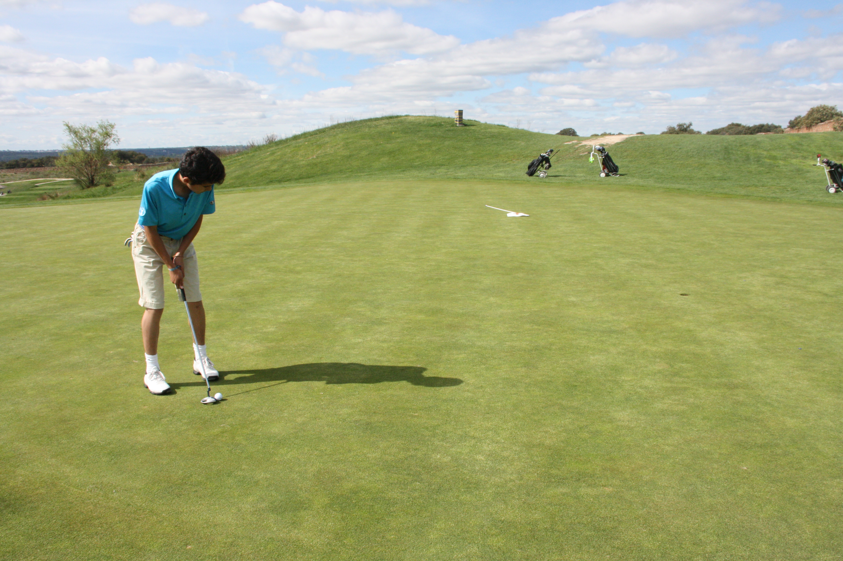

Achieving reliability is why much of the greenstaff’s time is spent on maintaining the greens

This can be a cause of complaint from golfers, who do not appreciate that the very work they are against is integral to the production of healthy, quality turf and greater reliability on a consistent basis. It may be possible to gain more support for greenkeepers and the occasional disruptive work they have to undertake if it can be demonstrated that the disruption brought about by essential cultural practices is greatly offset by the much greater length of time that greenkeepers are able to present top quality surfaces as a direct consequence of that work.

The study

This study investigated the influence of cultural practices to the reliability of greens at the Centro Nacional over a 12 month period, from 15 August 2013 to 15 August 2014. To achieve this, a protocol was designed for obtaining and interpreting data.

For the experiment, six of the 18 greens at the Centro Nacional were selected. The grass cover to them all was creeping bentgrass (Agrostis stolonifera) with 20% annual meadow-grass (Poa annua). The greens were built in 2005 following the USGA Recommendations and had an average surface of 400-500 m².

Surface reliability was measured using the Greenstester, which consists of a curved V-shaped metallic ramp, set at a fixed angle by a straight support. The device is set level at the required distance from the hole for the test and golf balls are sent down the ramp from a release mechanism. After levelling and calibration, 10 balls are launched and a score of the number holing out is obtained. The expected outcome on a green of good reliability is 9 to 10 out of 10, with 6 out of 10 being considered the lowest acceptable value.

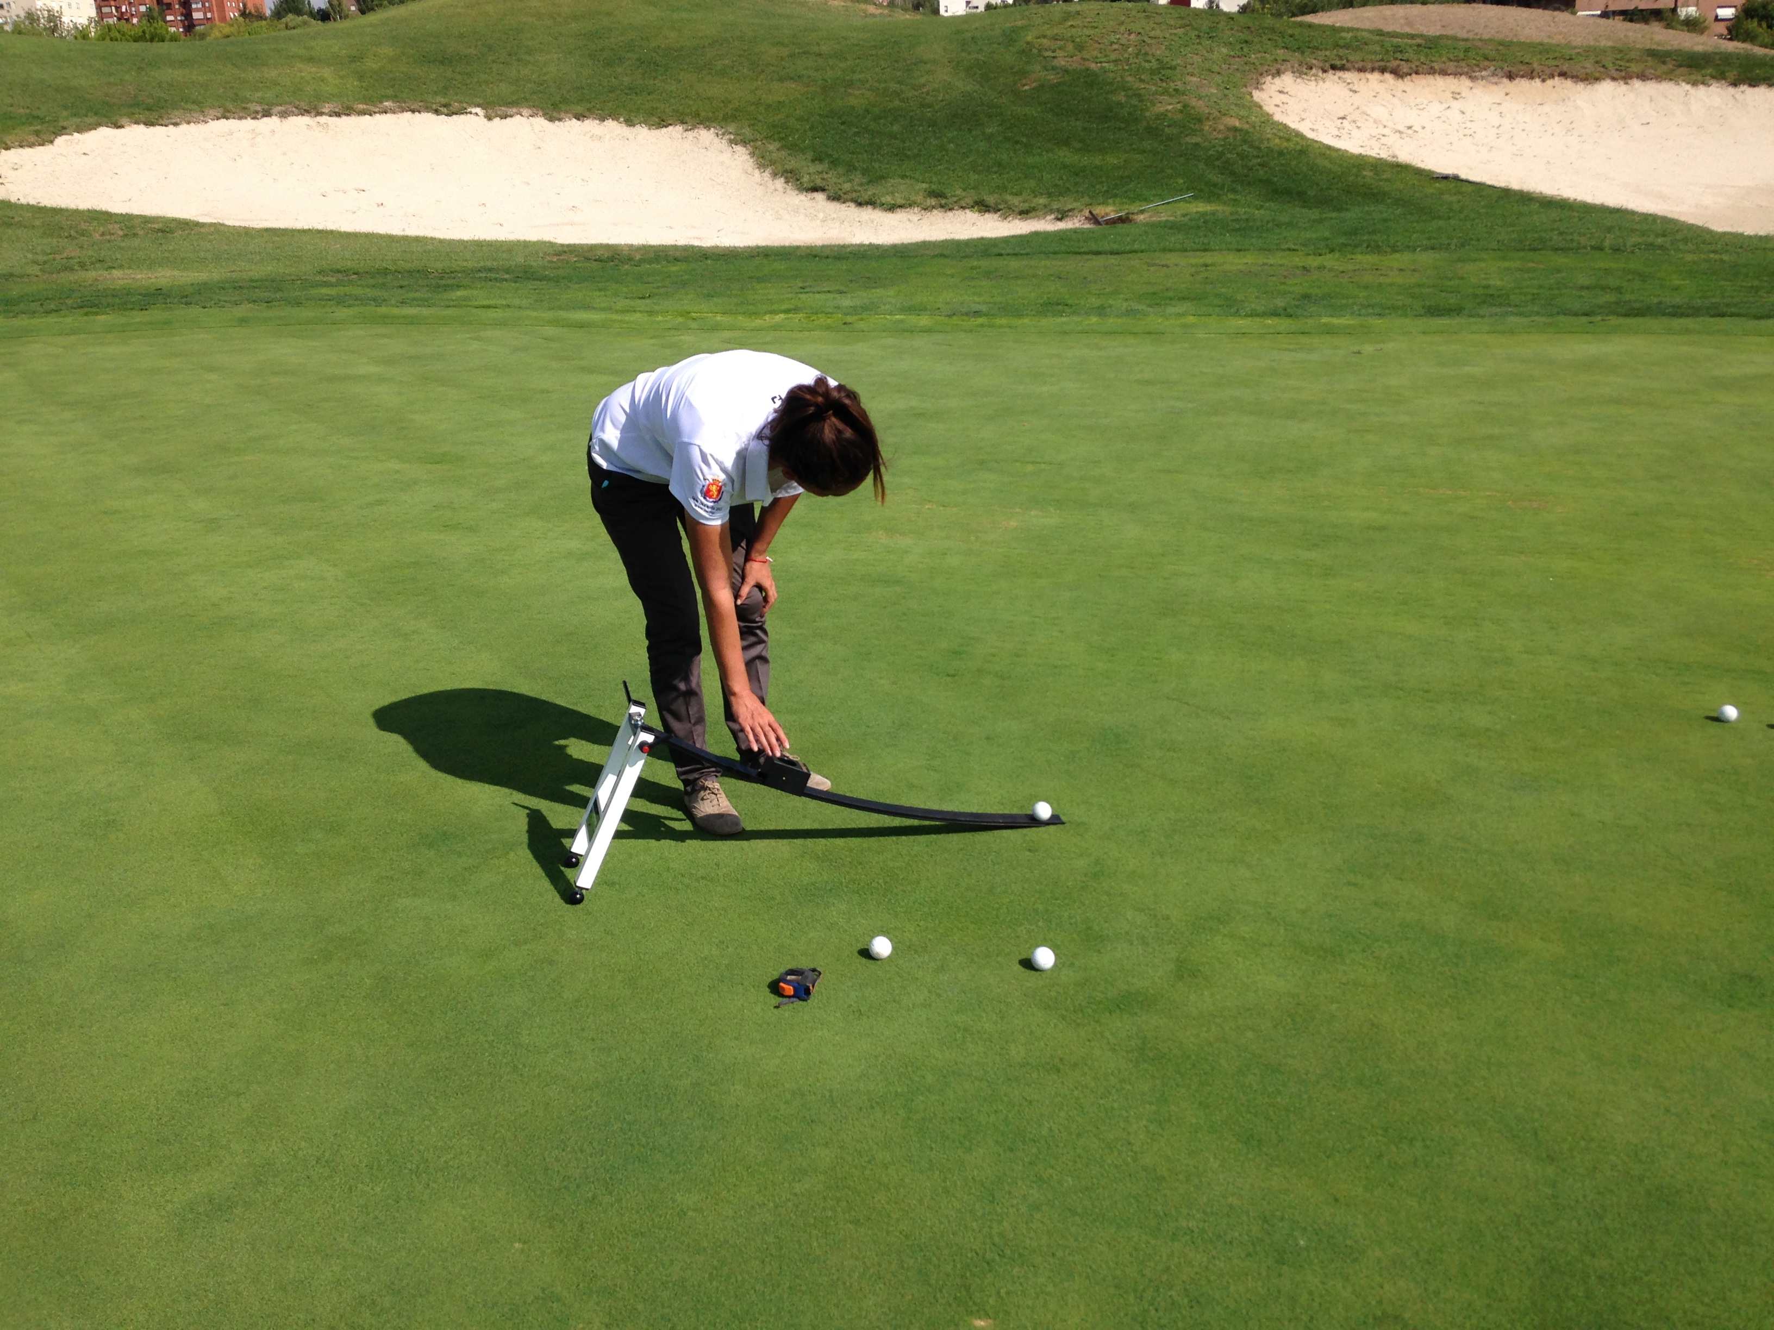

The Greenstester is used to measure the reliability of the putting surfaces at the Centro Nacional.

The reliability of the six greens was measured weekly, following the Greenstester manufacturer’s instructions. Measurements were taken with 10 balls of the same brand, released off the ramp from a 2 m distance to the hole location.

The combination of verticutting, micro-tining and top dressing was carried out in September 2013 and March 2014.

All of the test results were recorded, as were all of the cultural activities carried out to each green.

Results and discussion

The graph for all six greens shows how the reliability of holing out varied through the year and after cultivation treatments.

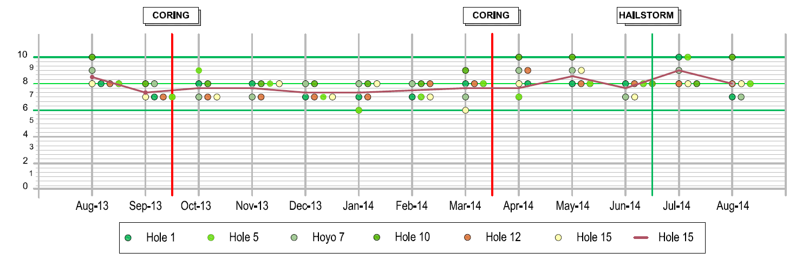
Graph showing the Greenstester readings and cultivation dates.

Although there is variation in assessment results between and within greens throughout the year of testing, the range in which most readings fell was a score of 7 to 8. Higher and lower scores were obtained and these relate, in part, to the immediate effect and longer-term benefits of the cultivations.

Reliability scores decreased during August and the first week of September, due to the increased stress the turf was suffering because of high temperatures and low rainfall. One of the most notable influences on the reliability readings was the amount of Poa annua present in the greens. High temperature stress impacts on this grass more than on the creeping bentgrass. Internal contouring within greens was seen to have an effect on this, with the greens not having such severe slopes coping much better under stress periods, and consequently the reliability to such greens did not decrease during these months.

The cultural practices did not cause deterioration in reliability below the acceptable level as determined by the Greenstester. The scores obtained a week after the micro-tining in September, the time it took to achieve recovery, were higher than the ones obtained immediately before. This indicates that the cultivation and remedial measures produced good results and that disruption to the provision of smooth putting surfaces was limited. It should also be noted that the cutting during the week of the September cultivations was higher than normal (4.2 mm compared to the norm at 3.8 mm) and fertiliser application was also completed, both of which can be detrimental to ball roll. The remedial treatment of rolling the greens was implemented prior to the Greenstester assessment.

Through the winter period of October through to February, growth decreases considerably, so during this period the cutting frequency is lower and there is practically no irrigation. This is reflected in the relatively low scores being recorded and, in the opinion of the researchers, this is due to the accumulation of organic matter over the summer months of strong growth and a lower frequency and intensity in cultural treatments during the winter months, in which the plant enters a latent state.

For the week of the March 2014 cultivation, the cutting height was higher than usual but the greens were not rolled on the day of the Greenstester assessment. The recovery time for the March micro-tining was two weeks, but optimum green performance in 2014 occurred in the spring and early summer months after cultivation works. From April to August the scores mainly stayed within the 7 to 9 range. However, a hailstorm only hours before a measurement in late June caused damage similar to the impact of micro-tining.
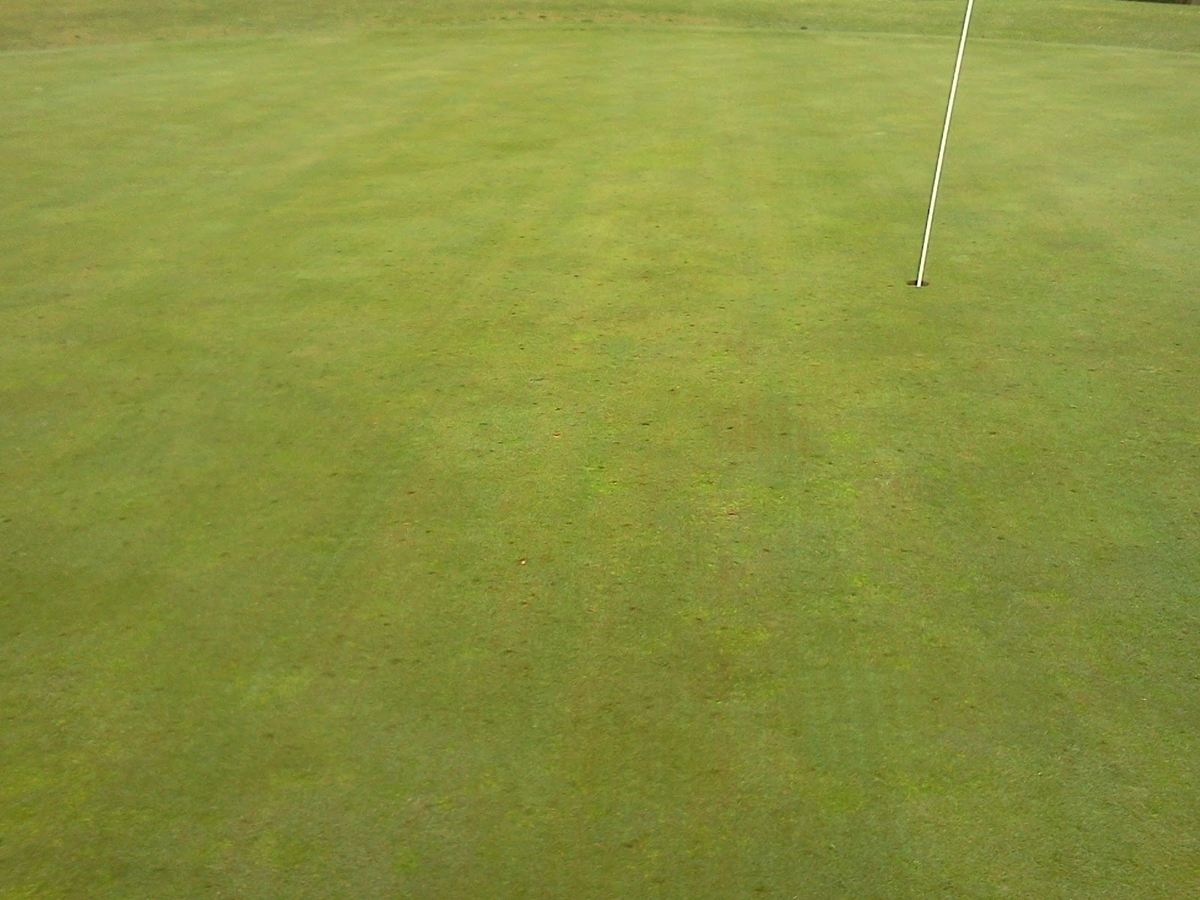

Weather-related stress impacts on surface reliability.

Conclusions

The conclusions that can be drawn from this study are:

- the recovery time of the green to its prior condition after micro-tining varies from one to two weeks

- micro-tining improves reliability, thanks to the stimulation of stronger growth, once its immediate impact has been overcome

- rolling increases reliability and helps achieve optimal conditions after invasive culture activities

- the weather-related stress tolerance of different grasses impacts on reliability, but the intensity and frequency of cultural practices can overcome stress conditions caused by the weather

- green design can influence weather-related stress on the turf and, therefore, the reliability of the putting surface, with severely contoured greens suffering the most

- severe weather incidents, such as hailstorms, affected the greens just as negatively as the micro-tining but, with remedial work, surface performance was restored within a week

- no relationship between fertiliser and growth regulator applications and the reliability of the greens was found

- cutting height was not a significant factor in reliability, but the cutting frequency was

- measuring the reliability of putting surfaces helps to assess the impact of cultivation practices and informs green management practices to present consistently good greens for golfers.



Case study information box

Playing performance
Royal Spanish Golf Federation, Spain

TOTAL GOLFERS 325,310
TOTAL COURSES 352
9-HOLE COURSES 87
18-HOLE COURSES 228
WEBSITE www.rfegolf.es

Related content
What golfer’s want
Assessing progress

Related links
R&A Evidence fields
R&A ‘Holing Out’ Test
Royal Spanish Golf Federation

