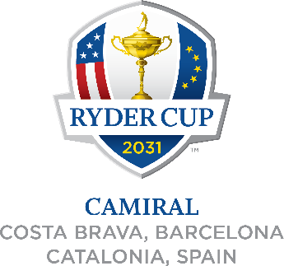

For immediate release Tuesday July 22, 2025

THE 2031 RYDER CUP TO BE PLAYED AT CAMIRAL IN COSTA BRAVA, NEAR BARCELONA, SPAIN
- Camiral to host biennial event for the first time
- Costa Brava, Barcelona region has a strong history of hosting world class sporting events
- Spain to host its second Ryder Cup, 34 years after Seve led Europe to victory at Valderrama
  - Spain becomes the first country in Continental Europe to host the Ryder Cup twice
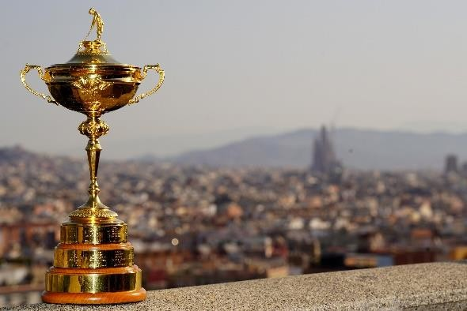

The Ryder Cup will return to Spain in 2031 when Camiral in Costa Brava, near Barcelona, hosts the biennial contest between Europe and the United States for the first time.

Camiral will follow Bethpage Black in New York (2025), Adare Manor in Ireland (2027) and
Hazeltine National in Minnesota (2029) as the venue for golf’s greatest team contest.

It will be the second time Spain has hosted the Ryder Cup, 34 years after the legendary Seve Ballesteros captained Europe to victory at Valderrama in 1997, becoming the first country in Continental Europe to host more than one Ryder Cup. That honour recognises the hugely significant contribution that Spanish golf has played in the history of the Ryder Cup, with 11 Spaniards having represented Team Europe, the joint second highest of any European country after England.

The stunning Costa Brava and Barcelona will provide the backdrop for the 2031 Ryder Cup, welcoming international visitors from across the world to a region renowned for its breathtaking coastline, world-class hospitality and vibrant cultural heritage.
Costa Brava and Barcelona have a rich legacy of hosting major international sporting events, including the 1992 Olympic Games in Barcelona, the F1 Spanish Grand Prix, the MotoGP Catalunya, and Champions League and La Liga football at Camp Nou, the home of FC Barcelona.

As part of the agreement for the region to host the Ryder Cup in six years time, Estrella Damm, the brewing company founded in Barcelona in 1876, will become the Official Beer of the 2031 Ryder Cup. They will also become the title partner of the DP World Tour’s Estrella Damm Catalunya Championship for five years beginning in 2026, with the 2028, 2029 and 2030 tournaments taking place at Camiral.

Guy Kinnings, Chief Executive of the European Tour Group, said: “Today’s announcement not only recognises Camiral as one of Europe’s leading venues, but also the considerable contribution Spanish golf has made to the proud history of the Ryder Cup.
“The Ryder Cup has grown significantly since Spain last hosted it in 1997. It is one of the world’s leading sporting events, which brings significant economic benefits and global exposure to a host region and country, so we could not be happier to be taking it to Costa Brava and Barcelona for the first time, and to Spain for the second time.
“This agreement has taken many months of collaborative discussions, so we are grateful not only to Denis O’Brien and his team at Camiral, but also to the Government of Catalonia, the Spanish Government, the Province of Girona and Barcelona Tourism for their vision and commitment to hosting this major global event. We have also secured significant support from the private sector in Costa Brava and Barcelona, including Estrella Damm’s long-term commitment, which will play a big role in the road to Ryder Cup 2031 as we showcase the region to our global audience.”

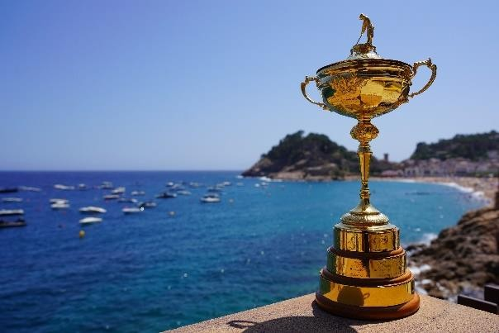

Jose Manuel Rodriguez Uribes, president of the Consejo Superior de Deportes, said: “The Government of Spain welcomes the selection of Camiral as the host venue for the 2031 Ryder Cup — a global sporting event that will showcase our country to millions of viewers around the world.
“The Ryder Cup is not only one of the most prestigious competitions on the international sporting calendar, but also an exceptional platform to demonstrate Spain’s ability to successfully host major 21st-century events, combining world-class infrastructure, unparalleled natural environment and a globally renowned tourism, cultural and culinary offering.
“Furthermore, hosting the Ryder Cup for the second time — 34 years after the historic edition at Valderrama — will firmly establish Spain as an international benchmark in the organisation of major sporting events. Without a doubt, this designation is also a tribute to the legacy of
Spanish golf and to our country’s unwavering commitment to sport — a sector that is also an

industry generating employment and economic growth — as well as to sustainable tourism and organisational excellence.”
The Minister of the Presidency of the Government of Catalonia, Albert Dalmau, said: “Hosting the Ryder Cup is a commitment to the territorial cohesion of the country and an opportunity to attract high-quality tourism linked to sport, generating a positive economic impact across the entire territory. It demonstrates that Catalonia once again has the highest ambitions to position itself on the international stage and to host top-level competitions.”

The Minister for Sports of the Government of Catalonia, Berni Álvarez, said: “All
stakeholders involved in the signing of this agreement are working to ensure that the benefits of the Ryder Cup reach every corner of Catalonia. We have defined a social legacy that will take shape through a comprehensive program, with sporting and social initiatives to promote the practice of golf, foster social cohesion, showcase golf courses across the region, and
implement sustainable actions. We are undoubtedly speaking of one of the most globally impactful sporting events, the result of a long and intense negotiation process to ensure a strong road to this historic milestone – from a sporting, social, and environmental perspective.”
Jordi Clos, President of the Executive Committee of Tourism of Barcelona, said: “Tourism of Barcelona is actively joining this major event, reaffirming Barcelona’s role as the gateway to Catalonia and as a driving force for high-quality, diversified, and sustainable tourism. The city
offers a wide-ranging and high-quality offer and is well prepared to meet the demands of a
discerning audience while connecting with the rest of the region. Ultimately, Barcelona, with its strong and internationally recognised brand, stands out as a key player in positioning Catalonia as a premium destination before a high-value global audience. The Ryder Cup is, in short, a
major opportunity for the whole country, and also for Barcelona as the gateway — and we will be there to open it to the world.”
Miquel Noguer, President of the Girona Provincial Council, said: “Hosting the Ryder Cup represents a unique opportunity for the Girona counties and for the entire country. We are talking about one of the world’s most high-profile sporting events, with a major economic
impact on the region — an impact that won’t be limited to the days of the competition but will
also extend to the lead-up and the aftermath. For the Provincial Council and for the Costa Brava Girona Tourism Board, golf is a strategic product. It helps combat seasonality, increases tourism spending, and positions us as a global reference point in this field.”
Denis O’Brien and Catherine O’Brien, owners of Camiral, said: “Hosting the Ryder Cup is the realisation of a long-held dream to bring golf’s greatest sporting event to Catalonia and Spain.
For the communities of Girona, Costa Brava and Barcelona, it will create immediate economic benefits, driving high value golf and leisure tourism in the years leading up to the 2031 Ryder Cup, and a long-lasting legacy built on the reputation of hosting one of the greatest sporting events in the world. We would like to thank the Catalan and Spanish Government and the Spanish Golf Federation for all of their support and we look forward to continuing our great relationship with Ryder Cup Europe.”
Juan Guerrero-Burgos, President of the Royal Spanish Golf Federation, said: “It is an honour for Spain to host the Ryder Cup for the second time in history. The previous experience at
Valderrama in 1997 was extraordinary. The economic impact, media coverage and more importantly, the legacy to our sport, tourism and awareness of golf in our country were unbelievable.

“Spanish golf has grown significantly in the last 25 years due to the incredible influence of that Ryder Cup in 1997, which helped to make golf accessible to everybody, many public golf courses were built and inspired new generations of players.

“The union of all public institutions and the support of Camiral will make possible another unforgettable Ryder Cup in 2031, where we will also pay tribute to all the Spanish golfers who have contributed so much to its history, with the legacy of Severiano Ballesteros always in mind.”

Spanish players have been part of some notable European Ryder Cup successes since 1979, with Sergio Garcia the all-time record points scorer from either side with 28½ points from his ten appearances.

The partnership between Ballesteros and Jose Maria Olazábal is also the most successful of all time, the legendary pair having won 12 points together for Team Europe, and like Ballesteros in 1997, Olazábal also captained Europe to an iconic victory, masterminding the ‘Miracle at Medinah’ in 2012.

Ballesteros and fellow countryman Antonio Garrido were the first players from Continental Europe to represent Europe in the contest in 1979 at The Greenbrier, and were later joined in Team Europe by José María Cañizares, Manuel Piñero and José Rivero. Subsequently, Olazábal and Antonio's son Ignacio were part of the winning team captained by Ballesteros at Valderrama 18 years later, along with vice-captain Miguel Angel Jiménez, who went on to play in four Ryder Cups.

More recently, Rafa Cabrera Bello was part of the European Team in 2016 and Jon Rahm has featured in the last three Ryder Cups, including the home victories in Paris in 2018 and in Rome two years ago. Both players formed successful partnerships with Garcia in 2016 and 2021 respectively.

There has been at least one Spaniard in the European Team in each Ryder Cup since 1979, the year players from Continental Europe became part of the biennial contest.

Camiral, ranked Spain’s number one golf and wellness resort, opened in 1999 and was acquired by Irish businessman Denis O’Brien in 2008. It has previously hosted the DP World Tour’s Open de España on three occasions, in 2000, 2009 and 2014, and the Catalunya Championship in 2022, as well as the Final Stage of the DP World Tour’s Qualifying School for nine consecutive years from 2008 to 2016.
It has been part of the European Tour Destination’s portfolio of world-class venues since its opening, when it was formerly known as PGA Catalunya.
Camiral, a Quinta do Lago Resort, is located just five minutes from Girona-Costa Brava Airport and one hour from Barcelona in north-eastern Spain. The 540-hectare forested estate boasts two championship courses, including the world-renowned Stadium Course. It is also home to the PGA NATIONAL Golf Academy and practice facilities, which have Europe’s largest trackman range and Europe’s largest short game area.

-ENDS-

